**Basic GP Connect Demonstrator Deployment**

The following document is a quick guide to getting the demonstrator up and running on a tomcat server for testing purposes. The setup and deployment is the easiest method and should be deployed using best practices if the demonstrator is going to be opened up to the world.

**Compile and Build**

The document assumes you have setup the project on your local machine to compile the project and generate the deployable WAR file. Details of how to build and run the demonstrator locally can be found in the README.md of the github repository (<https://github.com/nhs-digital/gpconnect>).

It is important web performing the build that the JavaScript is compiled first using the “grunt build” before the Java is compiled using the “mvn clean package”. This is because as part of the “mvn clean package” the compiled JavaScript is copied into the WAR file so it needs to be compiled first.

**MySQL**

1. From the MySQL website download the latest MySQL “Installer” and “Workbench” and install them to the machine.

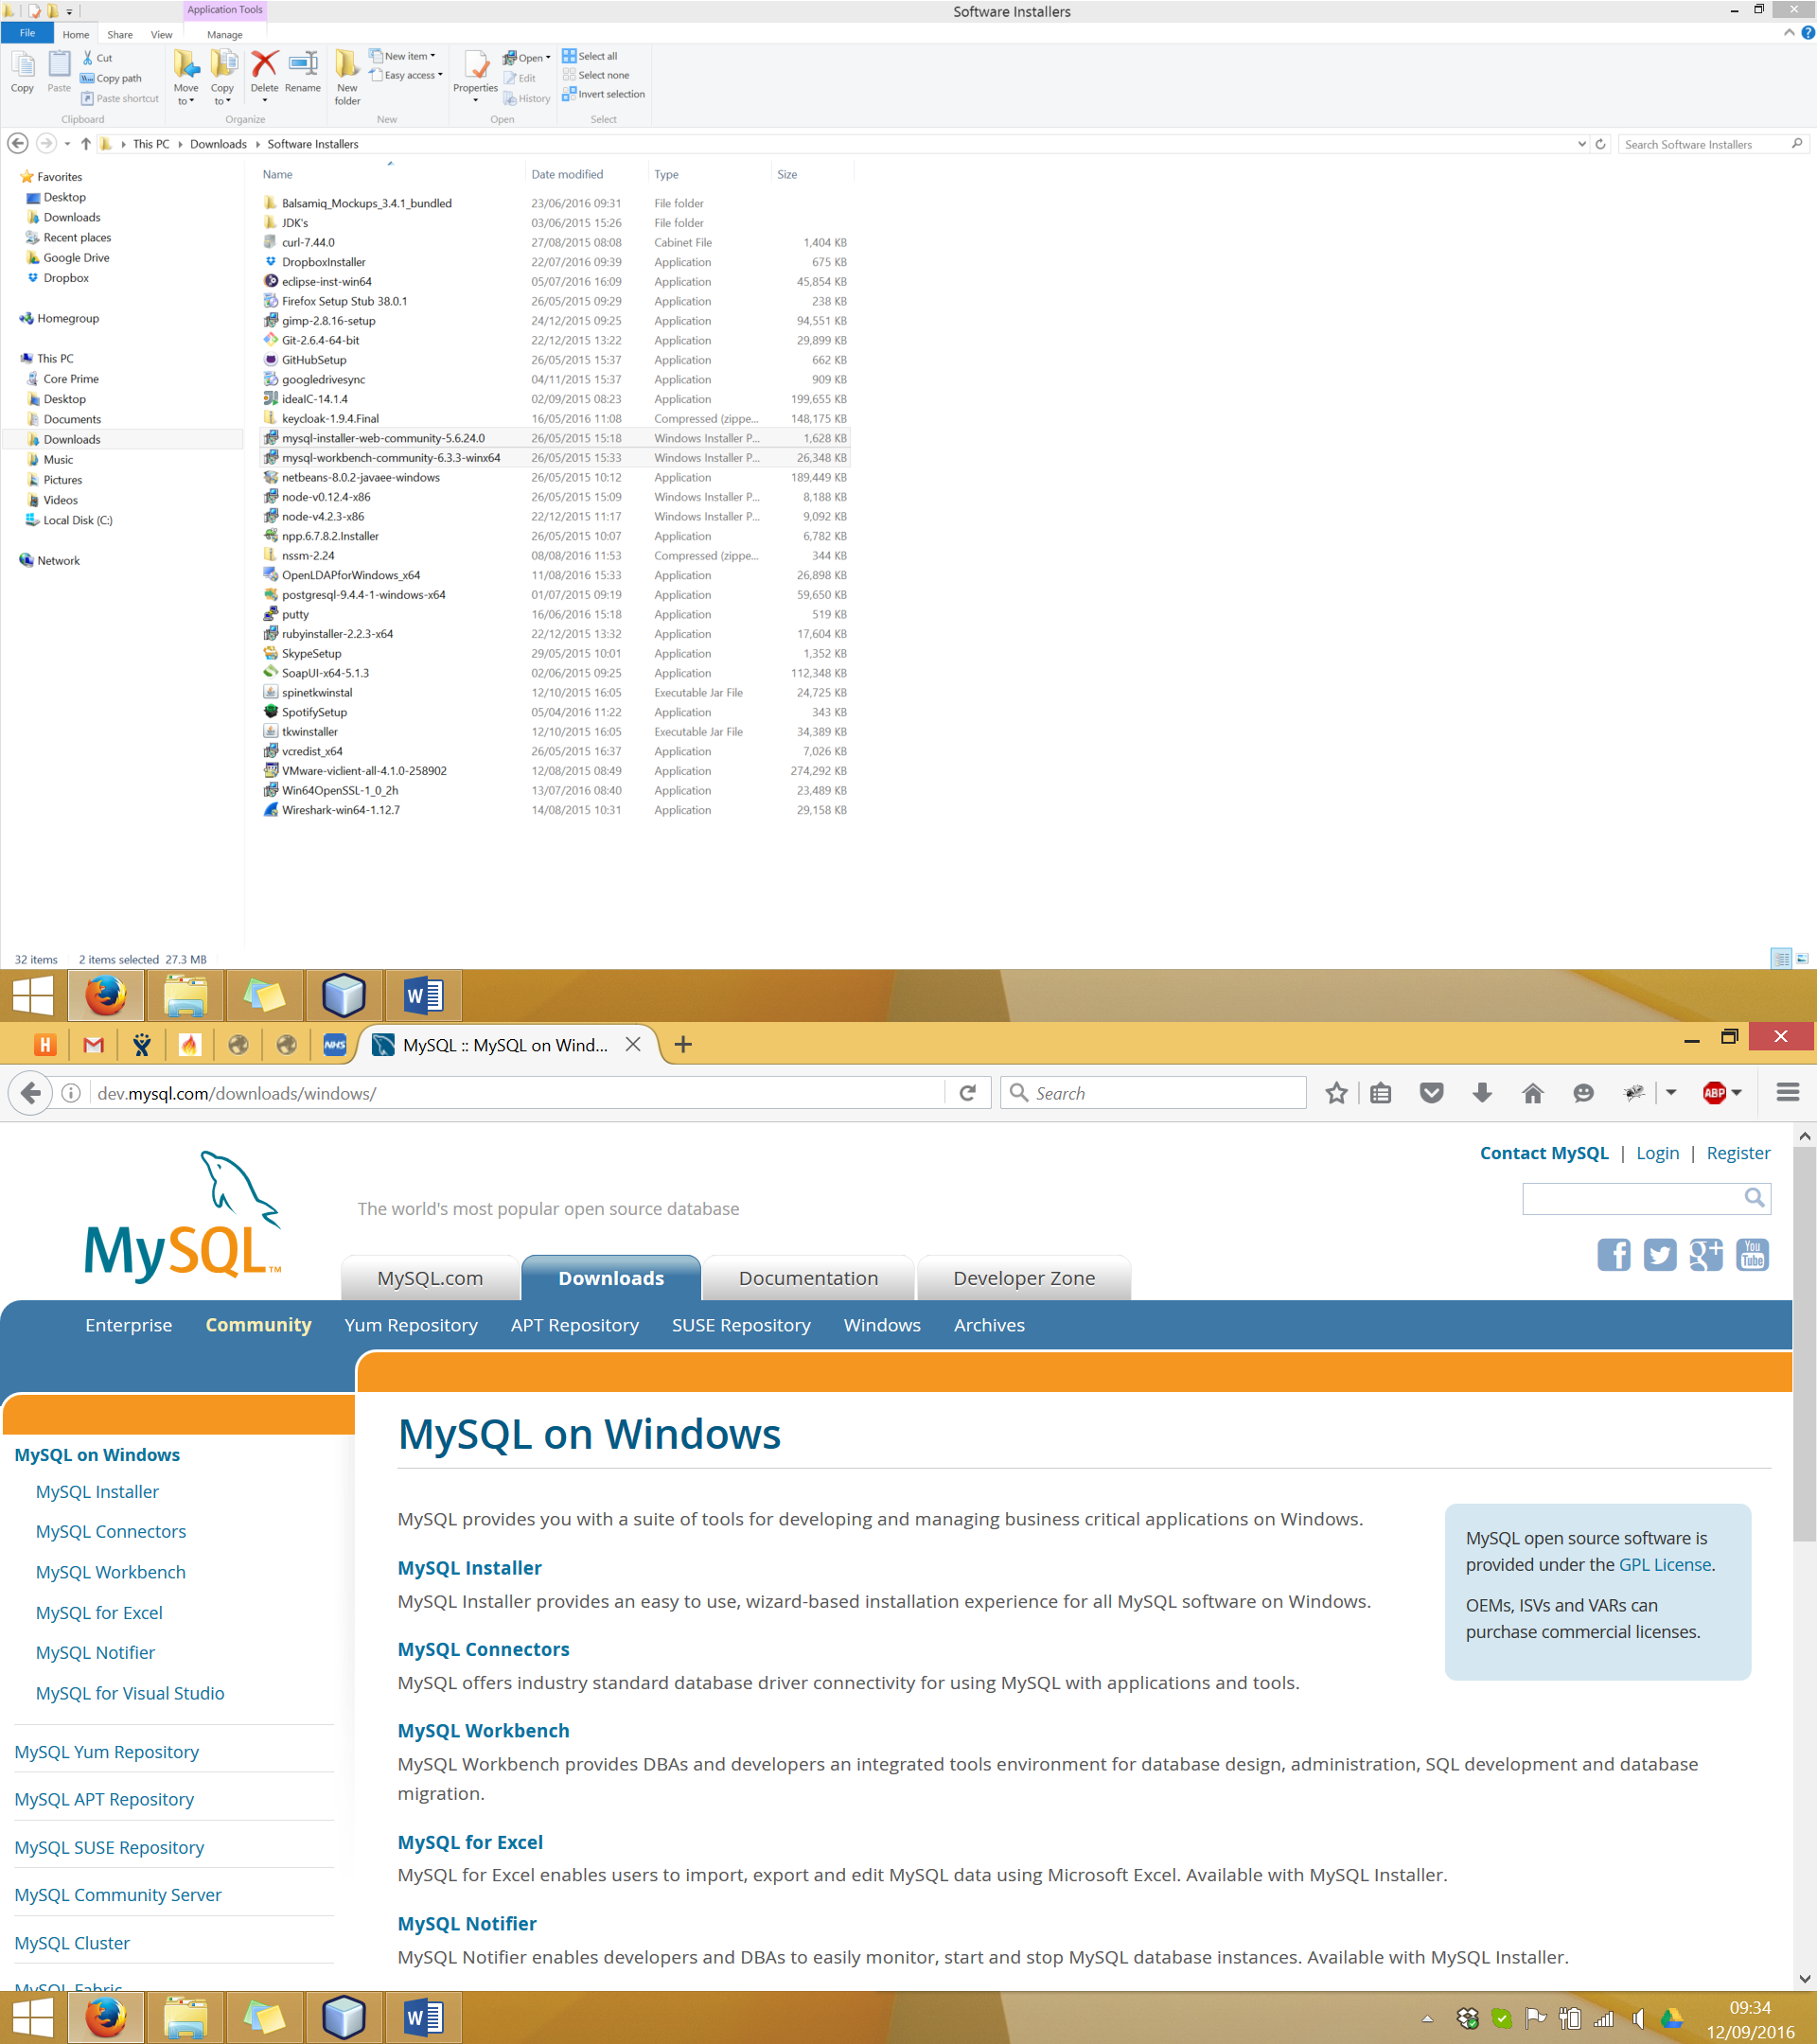

2. Open the MySQL Workbench and connect to your MySQL server instance. Open and run the scripts which can be found in the GP Connect Demonstrator project folder under the following path:

“\gpconnect-database\src\main\resources\sql\legacy”

You must run the “create_database_and_tables.sql” script first then you can run the other scripts in any order you want to.

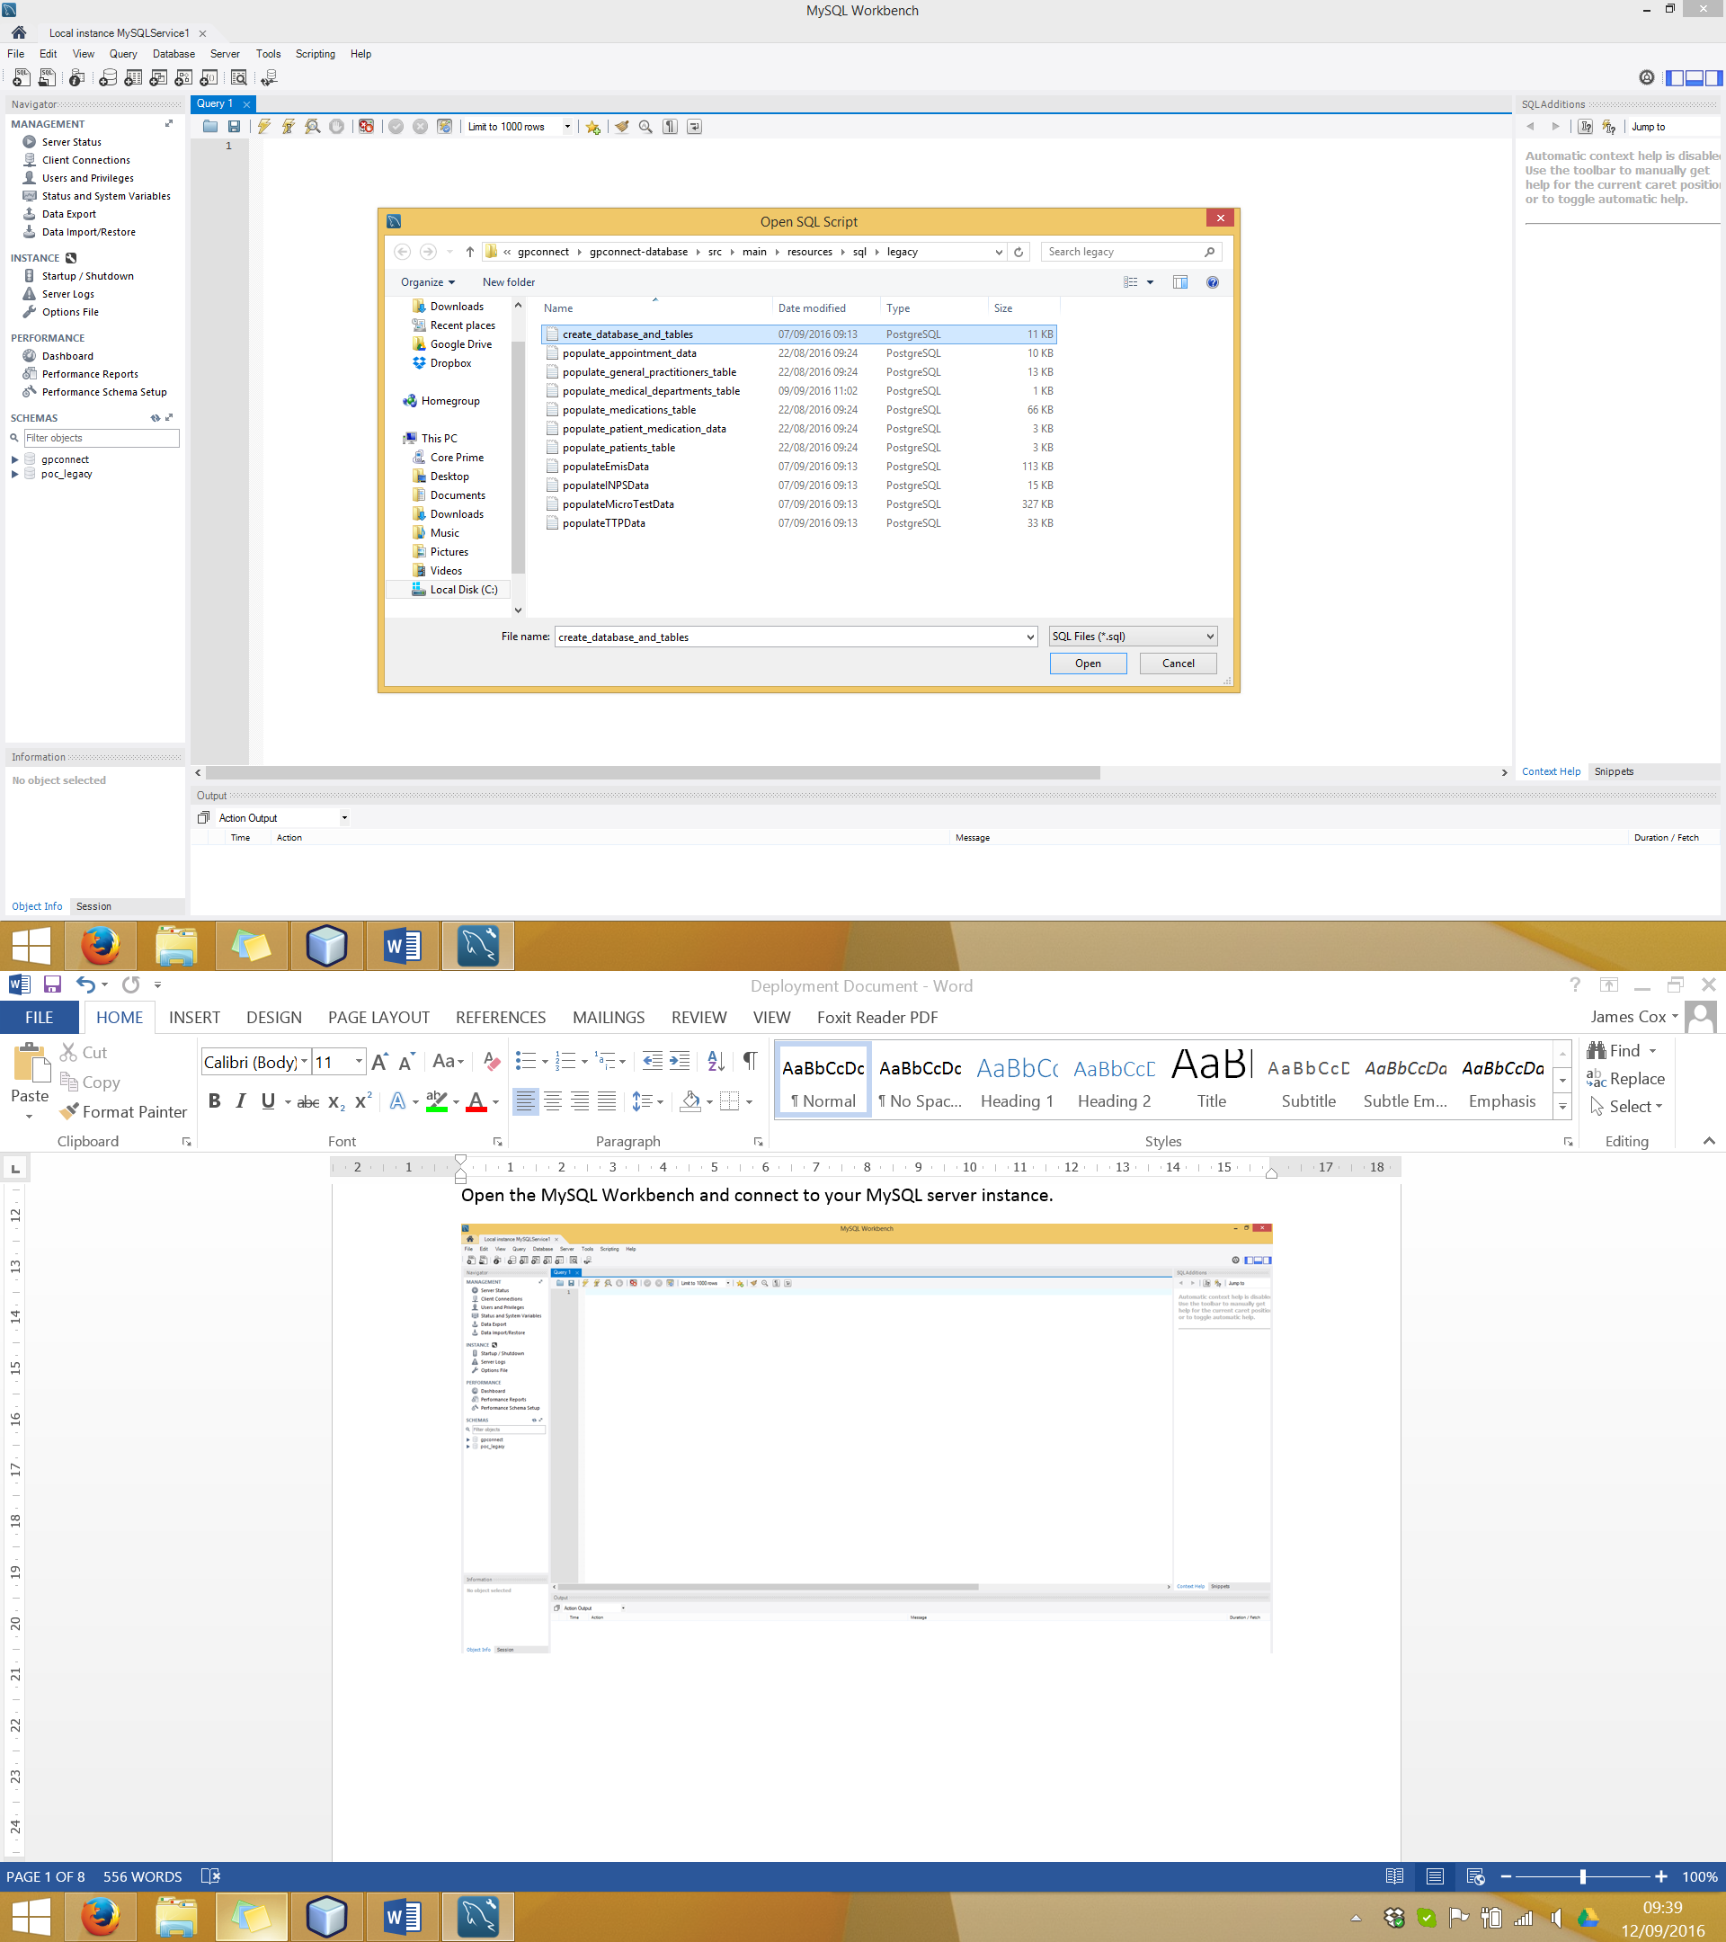

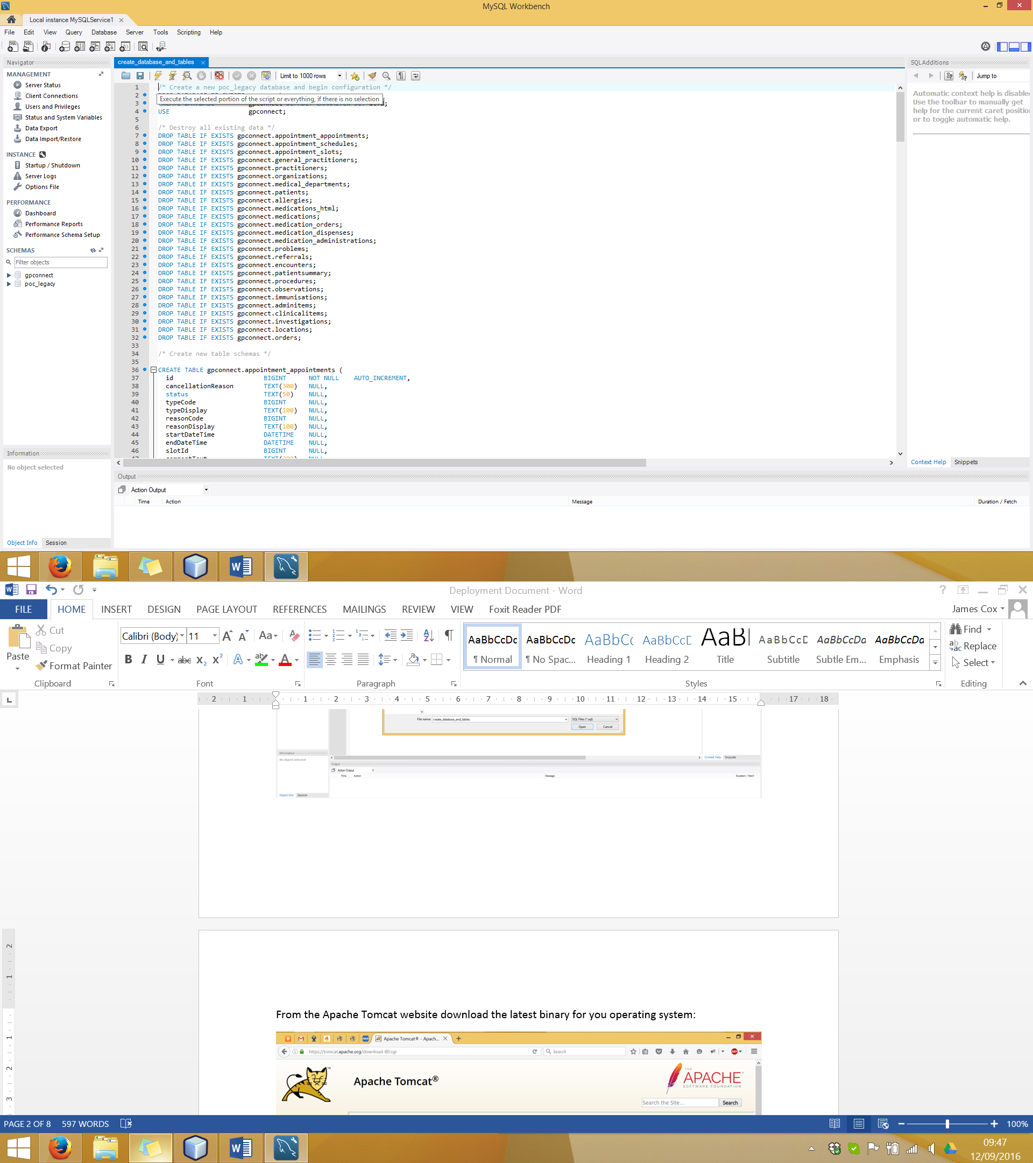

**Tomcat Server**

1. From the Apache Tomcat website download the latest binary for you operating system:

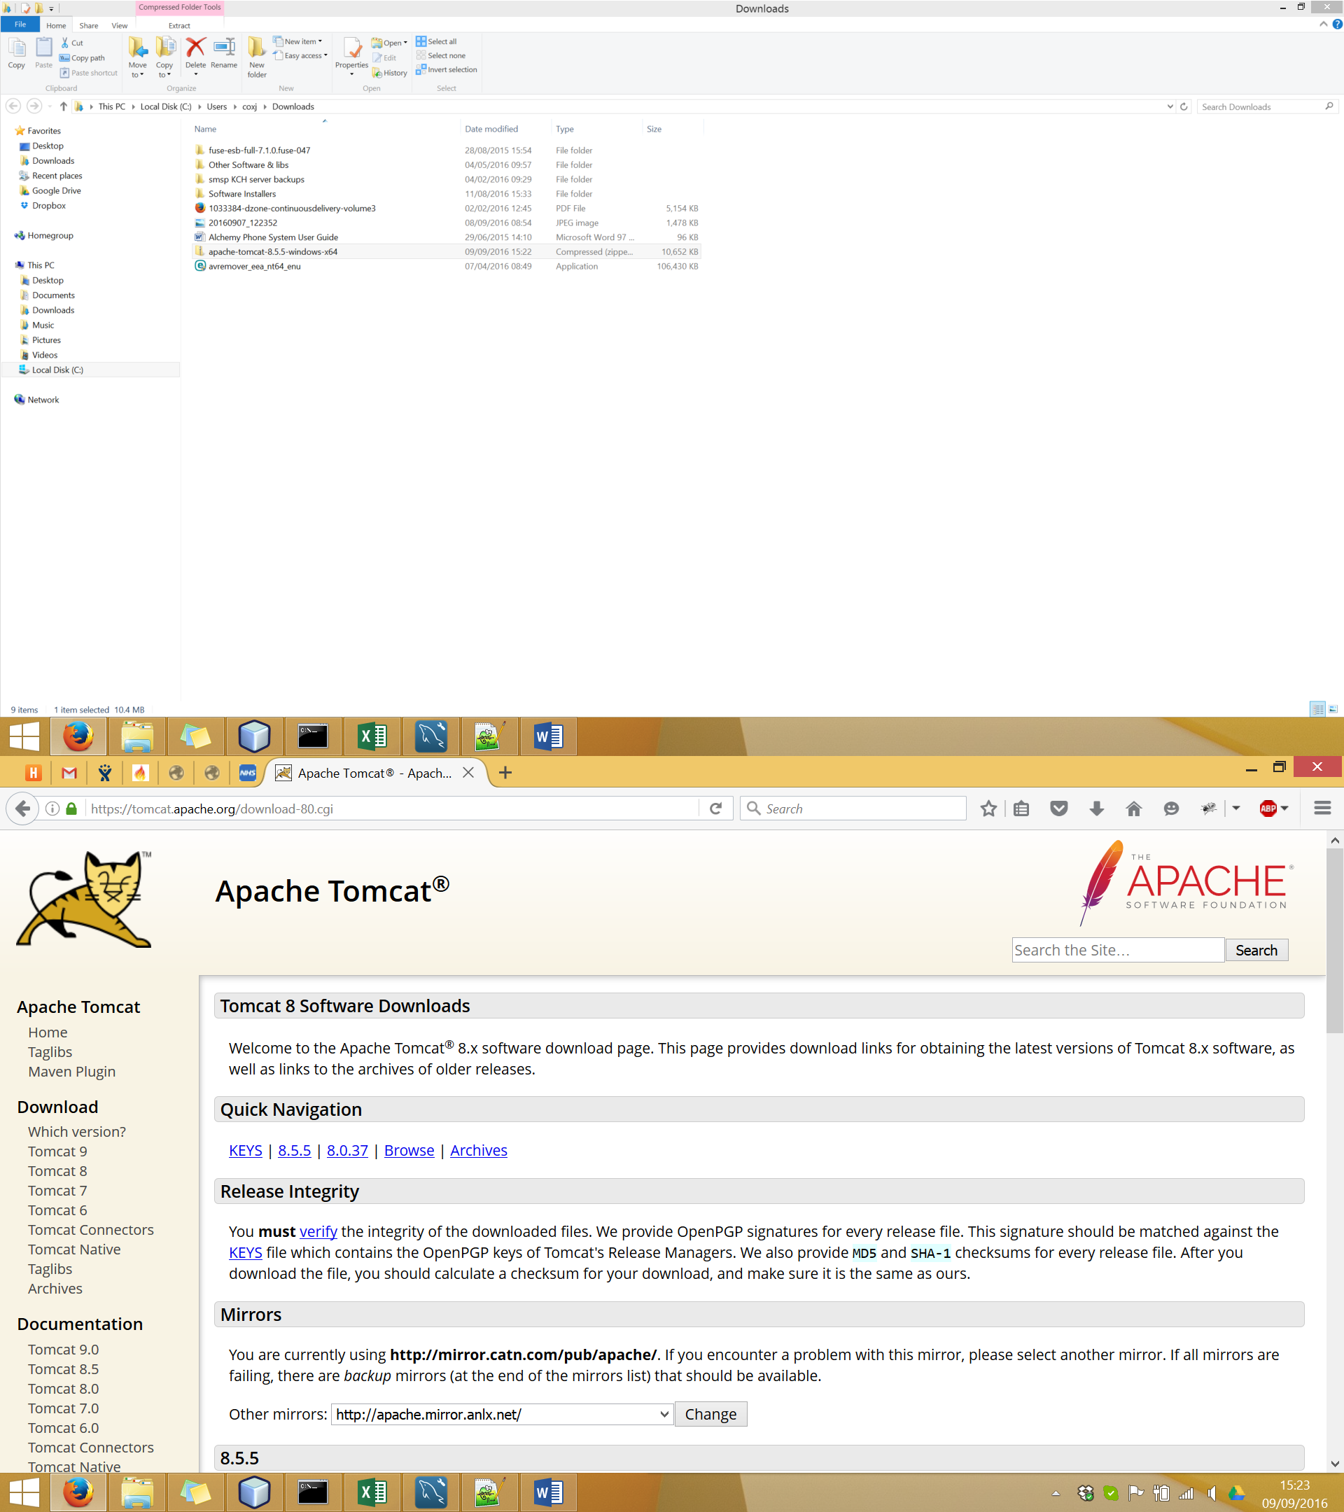

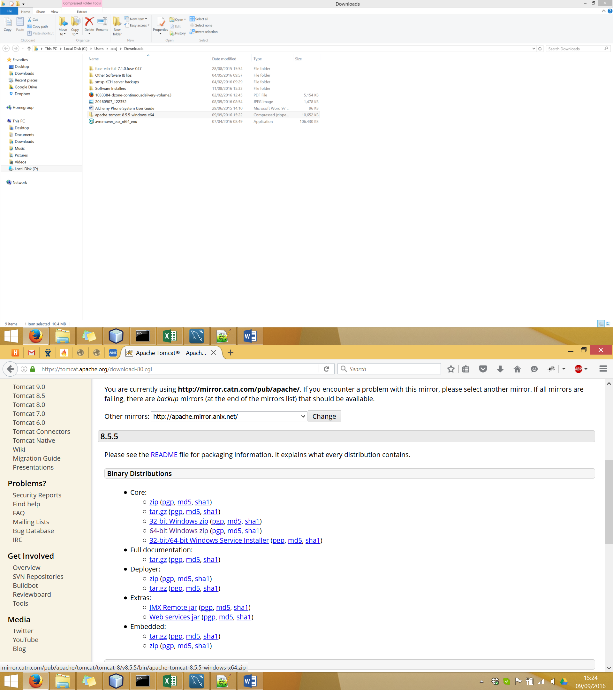

2. Copy the downloaded tomcat to an appropriate folder on the system where the GP Connect demonstrator will be deployed. Extract the content of the Zip file:

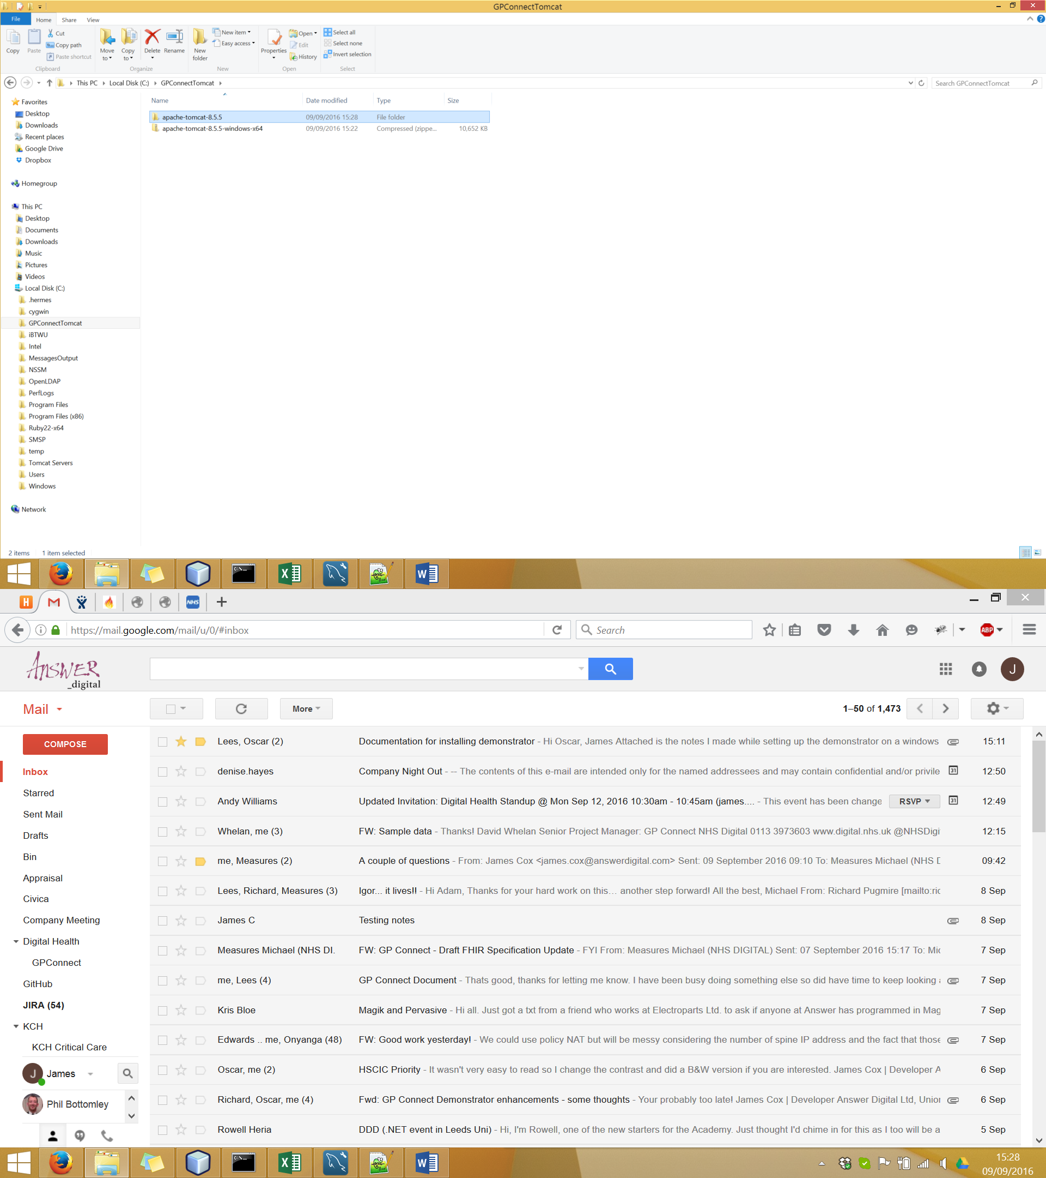

Delete all the content within the “webapps” folder of the tomcat server as these are not required:

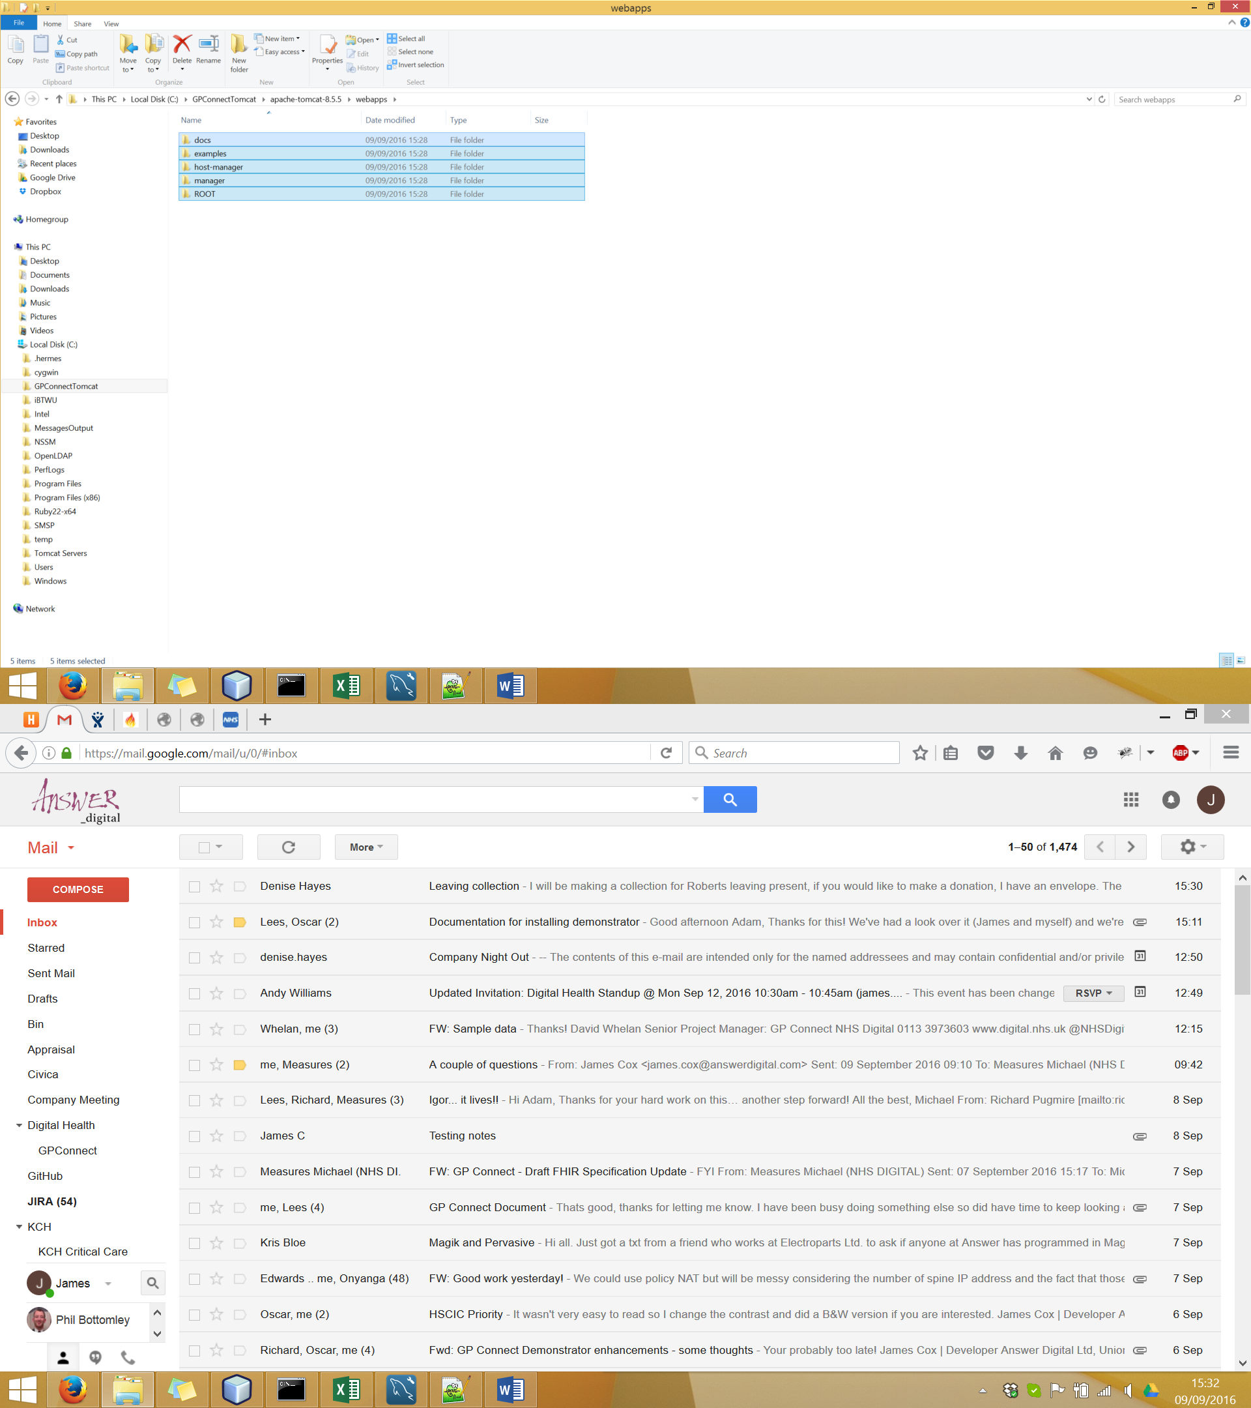

3. Copy the WAR file from project target file in the directory where you complied the project, to the webapps folder of the tomcat server, re-name it to “ROOT.war” and extract it into the same folder:

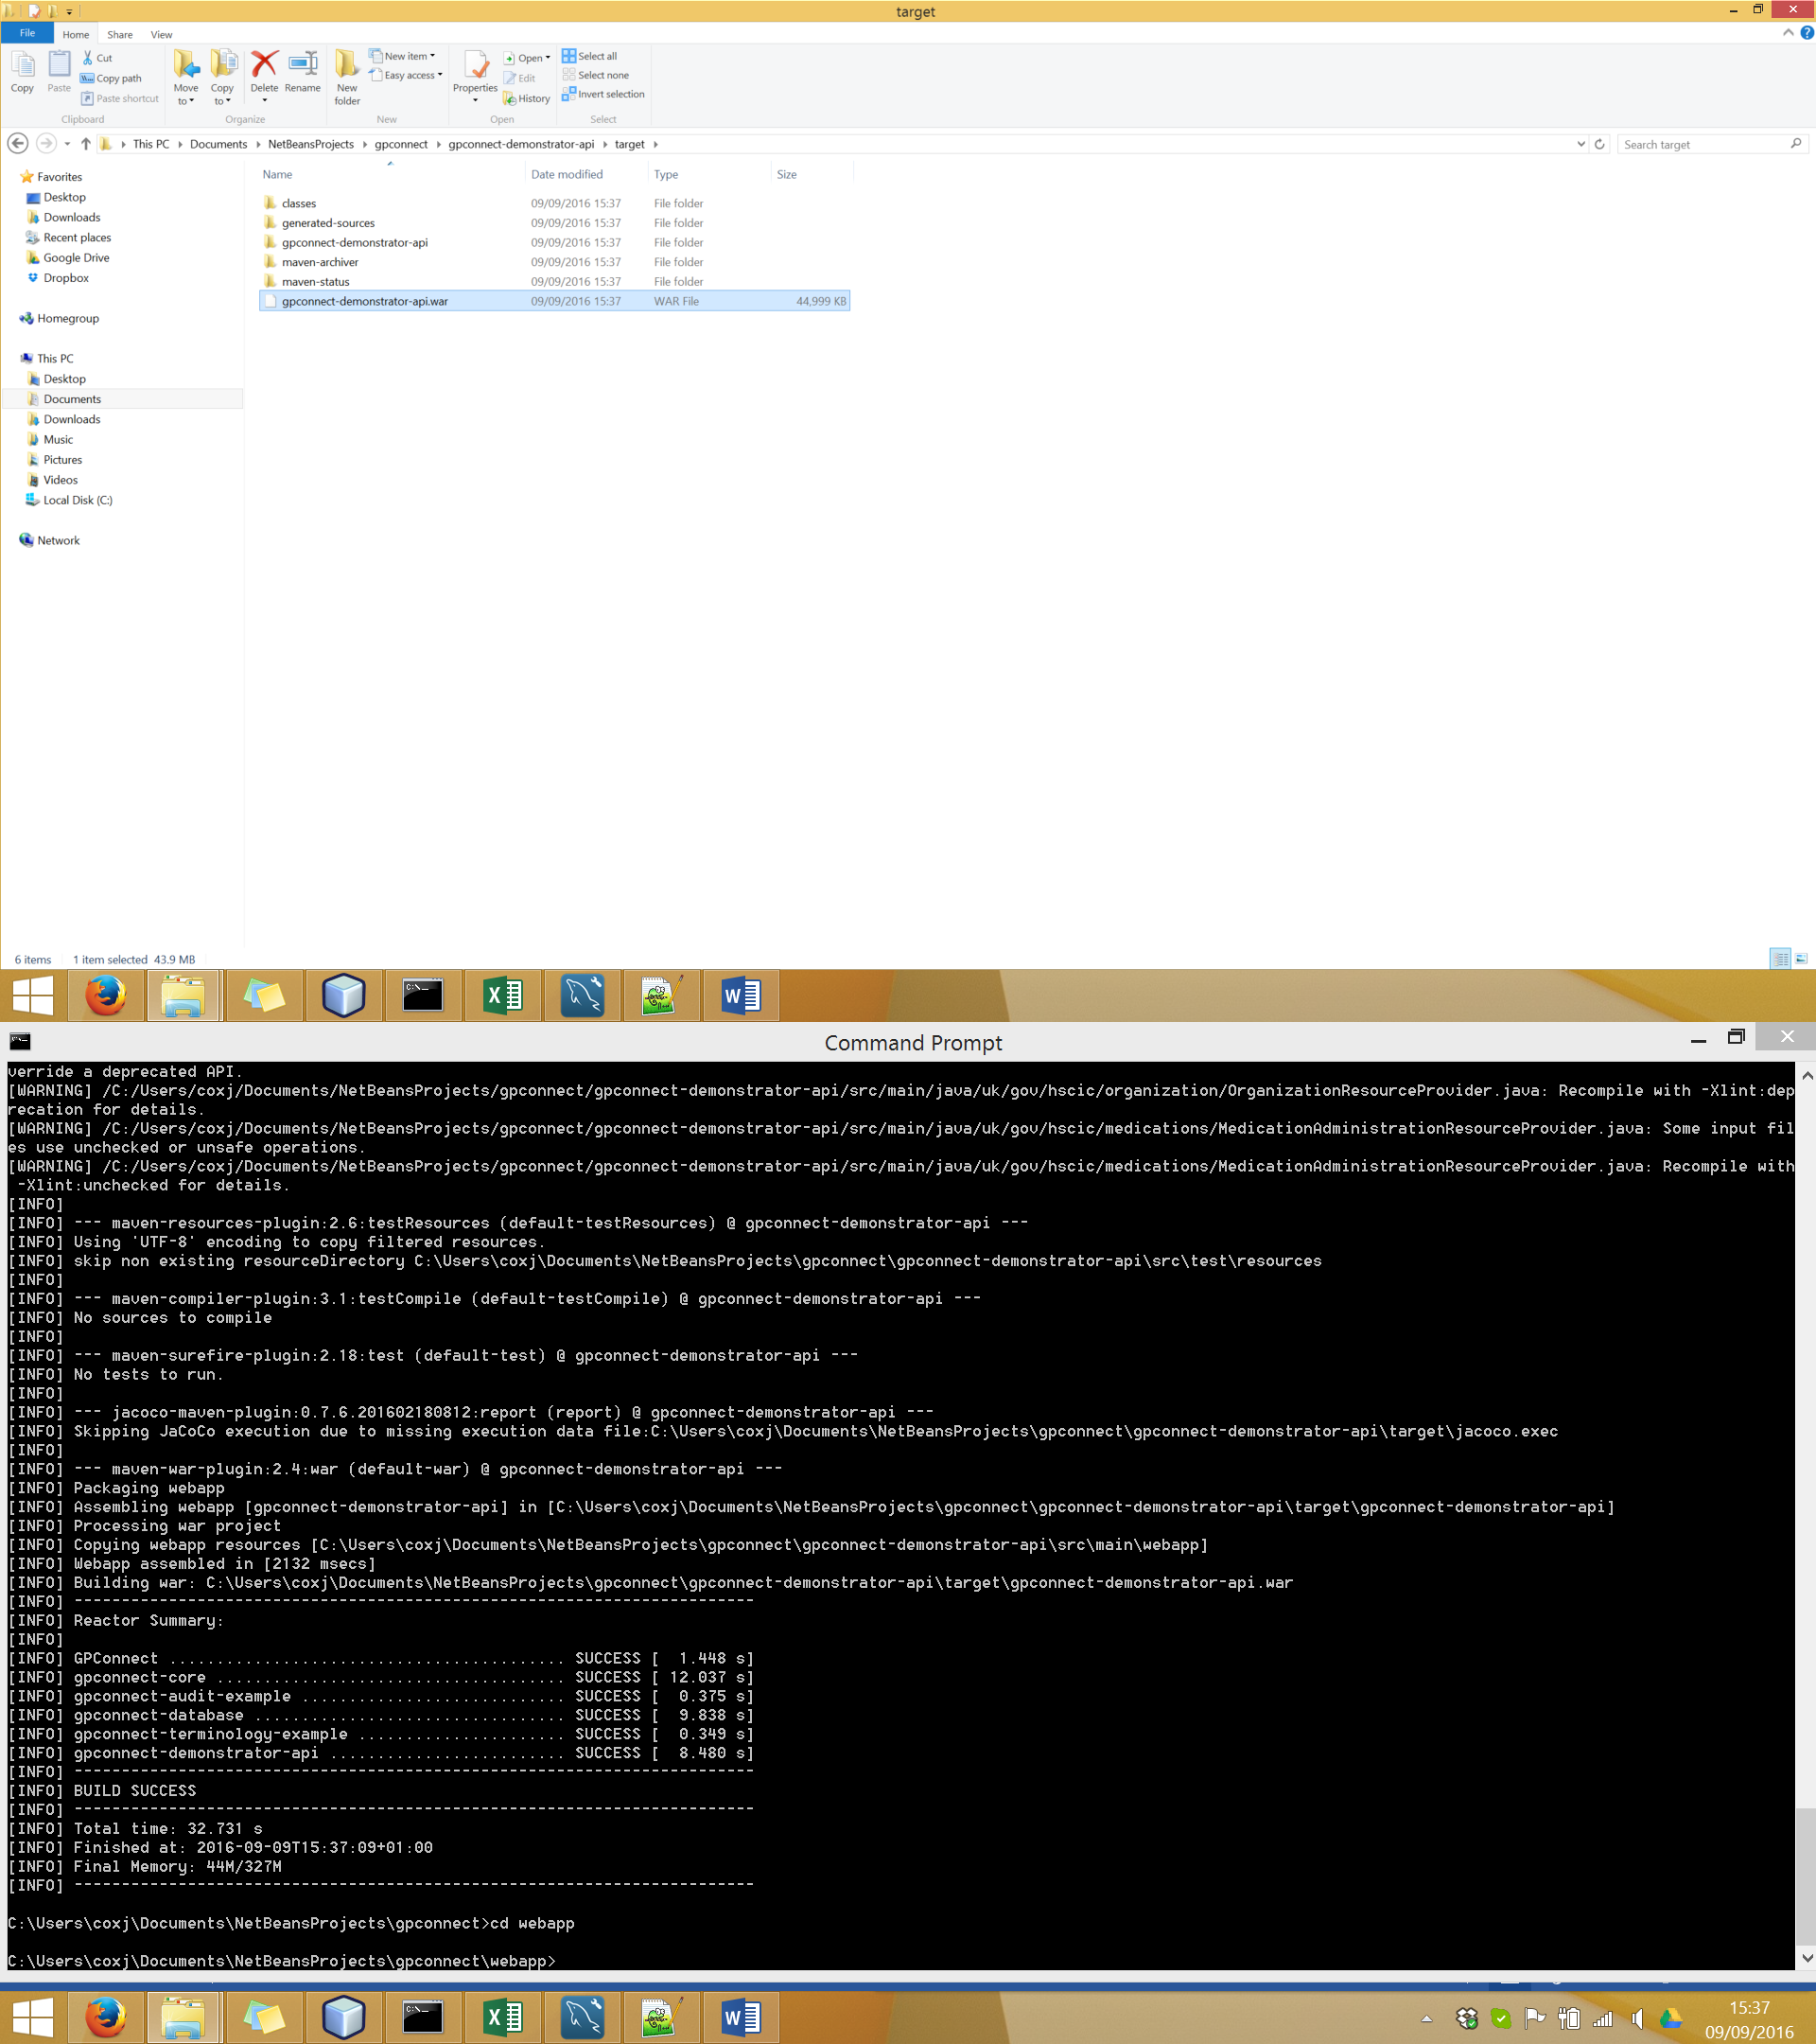

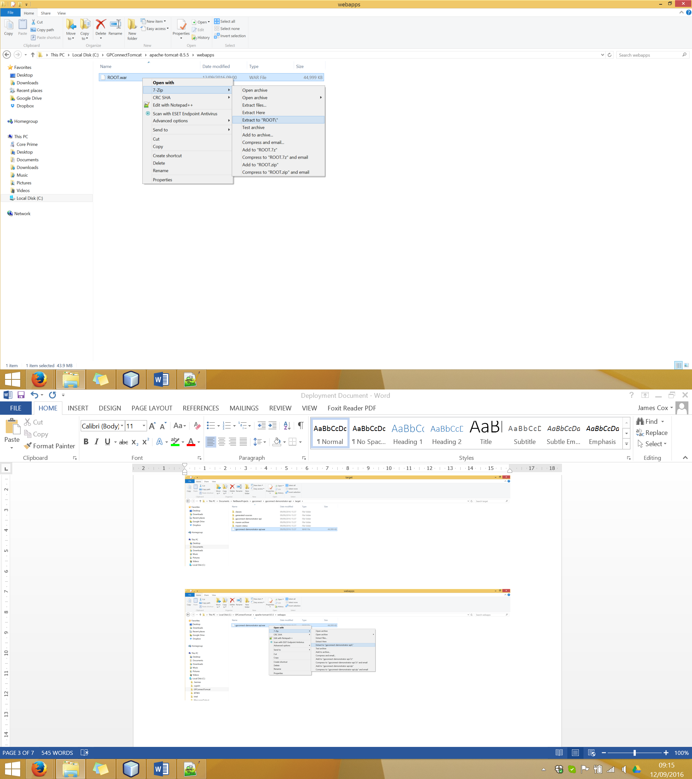

4. Copy across the Slots.txt file from the Root directory for the project folder over to the server. The location of the Slots.txt file on the server does not matter as its location will be configured in the application environmental variables.

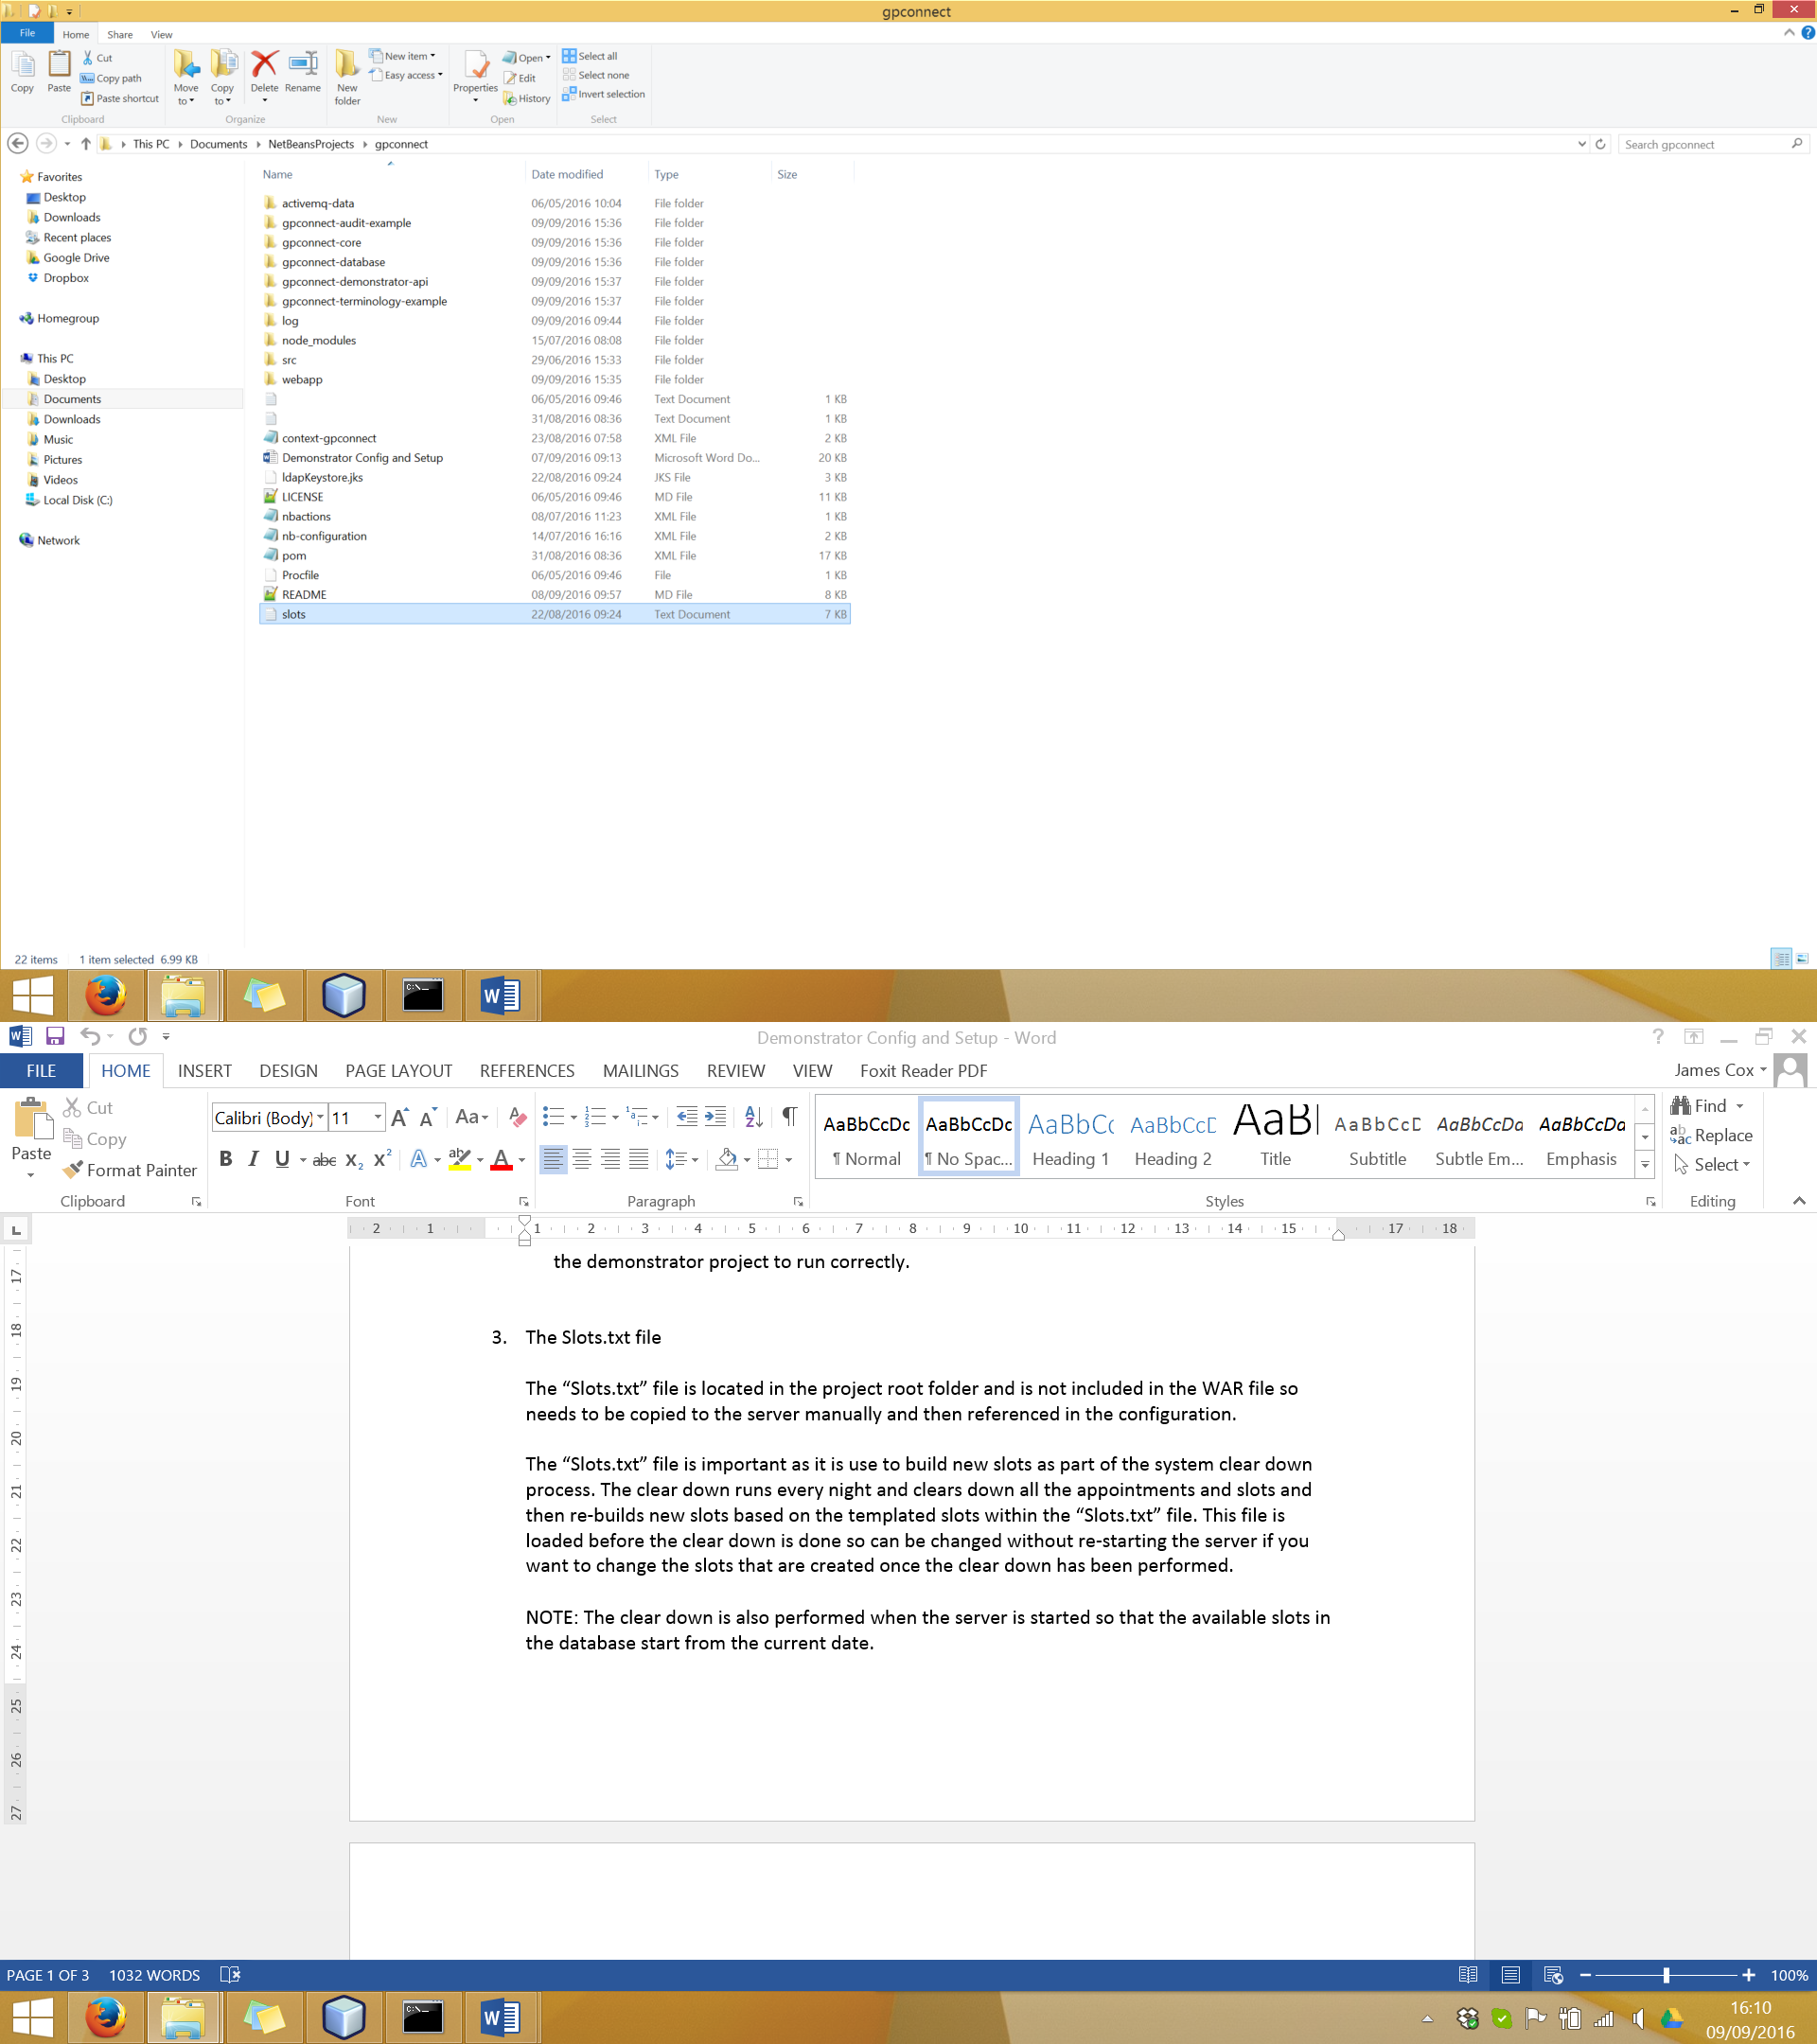

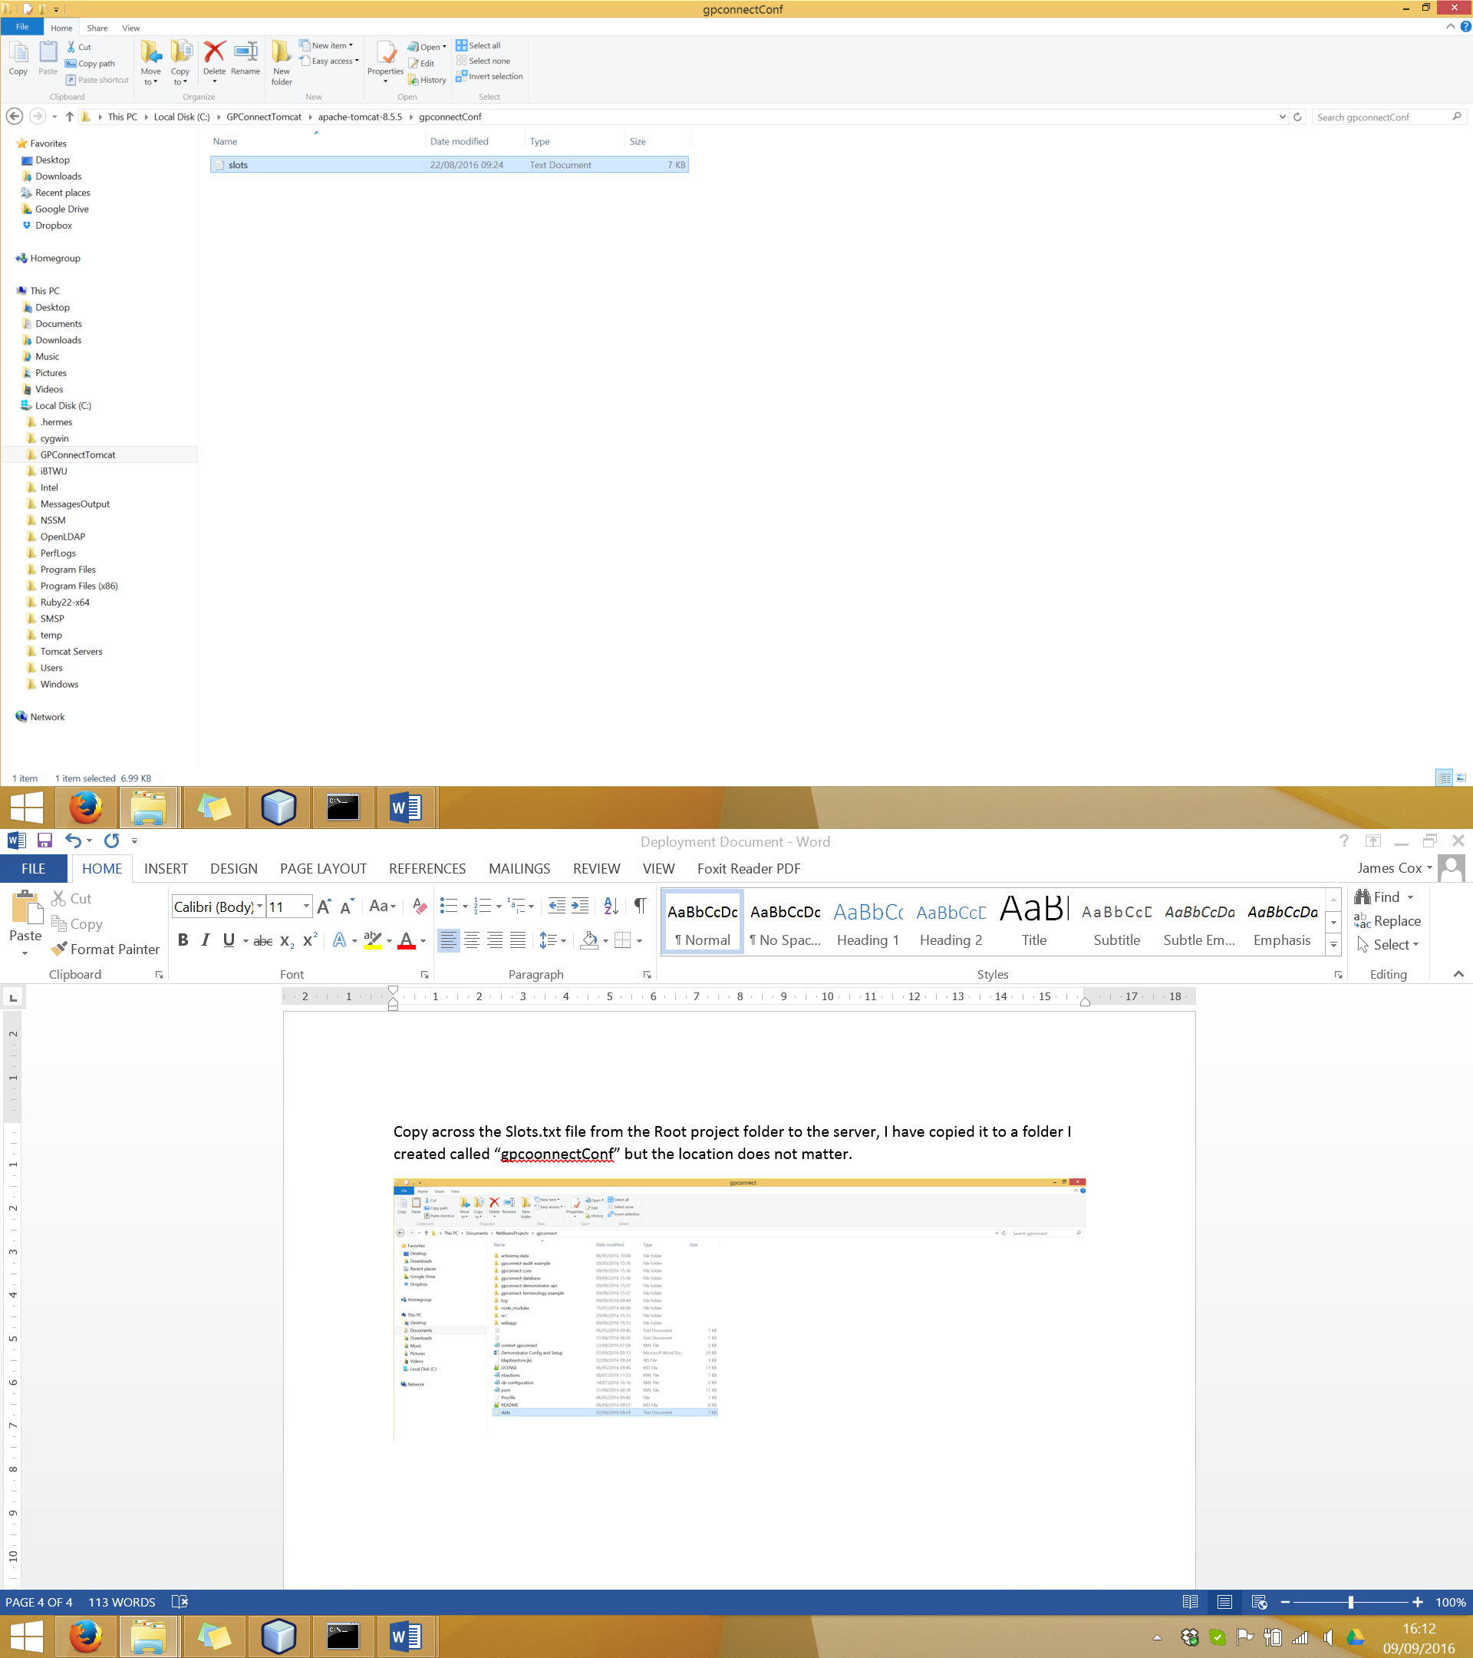

5. The following environmental properties need adding to the tomcat instance context for the GP Connect Demonstrator to use. The basic XML can be found in the project folder at the following path:

“\gpconnect-demonstrator-api\src\main\resources\config\tomcat-context-example”

There are two paths within the configuration that you will need to change to match your deployment.

<Environment name="legacy.datasource.vendor" type="java.lang.String" override="false" value="mysql"/>

<Environment name="legacy.datasource.host" type="java.lang.String" override="false" value="127.0.0.1"/>

<Environment name="legacy.datasource.port" type="java.lang.String" override="false" value="3306"/>

<Environment name="legacy.datasource.schema" type="java.lang.String" override="false" value="gpconnect"/>

<Environment name="legacy.datasource.username" type="java.lang.String" override="false" value="answer"/>

<Environment name="legacy.datasource.password" type="java.lang.String" override="false" value="answer99q"/>

<Environment name="legacy.datasource.showSql" type="java.lang.Boolean" override="false" value="false"/>

<Environment name="legacy.datasource.cleardown.cron" type="java.lang.String" override="false" value="0 1 1 * * ?"/>

<Environment name="legacy.datasource.refresh.slots.file" type="java.lang.String" override="false" value="C:\GPConnectTomcat\apache-tomcat-8.5.5\gpconnectConf\slots.txt"/>

<Environment name="ldap.context.url" type="java.lang.String" override="false" value="192.168.54.6"/>

<Environment name="ldap.context.port" type="java.lang.Integer" override="false" value="389"/>

<Environment name="ldap.context.useSSL" type="java.lang.Boolean" override="false" value="false"/>

<Environment name="ldap.context.keystore" type="java.lang.String" override="false" value="C:\ GPConnectTomcat\apache-tomcat-8.5.5\gpconnectConf\ldapKeystore.jks"/>

<Environment name="ldap.context.keystore.pwd" type="java.lang.String" override="false" value="password"/>

<Environment name="ldap.context.keystore.type" type="java.lang.String" override="false" value="JKS"/>

<Environment name="gp.connect.spineproxyconf.path" type="java.lang.String" override="false" value=" C:\ GPConnectTomcat\apache-tomcat-8.5.5\webapps\ROOT\spineproxy.json"/>

<Environment name="gp.connect.interactionwhitelist.path" type="java.lang.String" override="false" value="C:\ GPConnectTomcat\apache-tomcat-8.5.5\webapps\ROOT\interactionIdWhiteList.json"/>

<Environment name="gp.connect.provider.routing.file" type="java.lang.String" override="false" value="C:\GPConnectTomcat\apache-tomcat-8.5.5\webapps\ROOT\providerRouting.json"/>

The properties highlighted yellow are to do with the overnight clear down of the appointments and tasks:

* The “legacy.datasource.cleardown.cron” is a cron string which tells the demonstrator to run the clear down at 01:01 in the morning every night. This can be changed to run the clear down whenever you want. The clear down is run on start-up of the server to make sure the slots within the database start from the current date.
* The “legacy.datasource.refresh.slots.file” is the absolute path to the slots file which contains the template for the slots to populate when the clear down is performed. It has to be the absolute path, using a relative path may cause issues.

The property highlighted green is the path to the keystore used to talk to the SDS. It must be the absolute path and cannot be a relative path. The other “ldap” configuration properties can be used to point the demonstrator to use an instance of the SDS to lookup endpoints for the interactions before making the FHIR requests to get data.

The property highlighted blue is the file which mocks the endpoint lookup service if the demonstrator cannot reach the SDS to do the endpoint lookup. This path needs changing to be the absolute path to the file on your deployment otherwise the demonstrator will not find the file.

The file you need to add the XML into, is the “context.xml” file in the tomcat server “conf” directory.

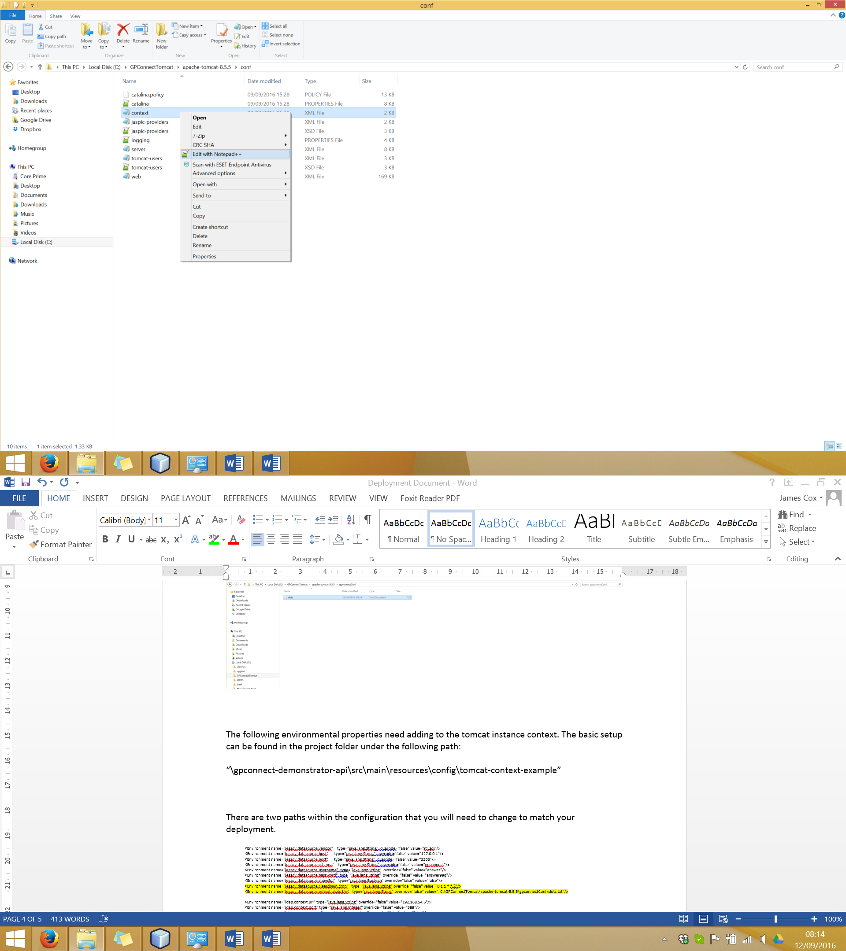

Your context file should look something like the one in the screenshot below.

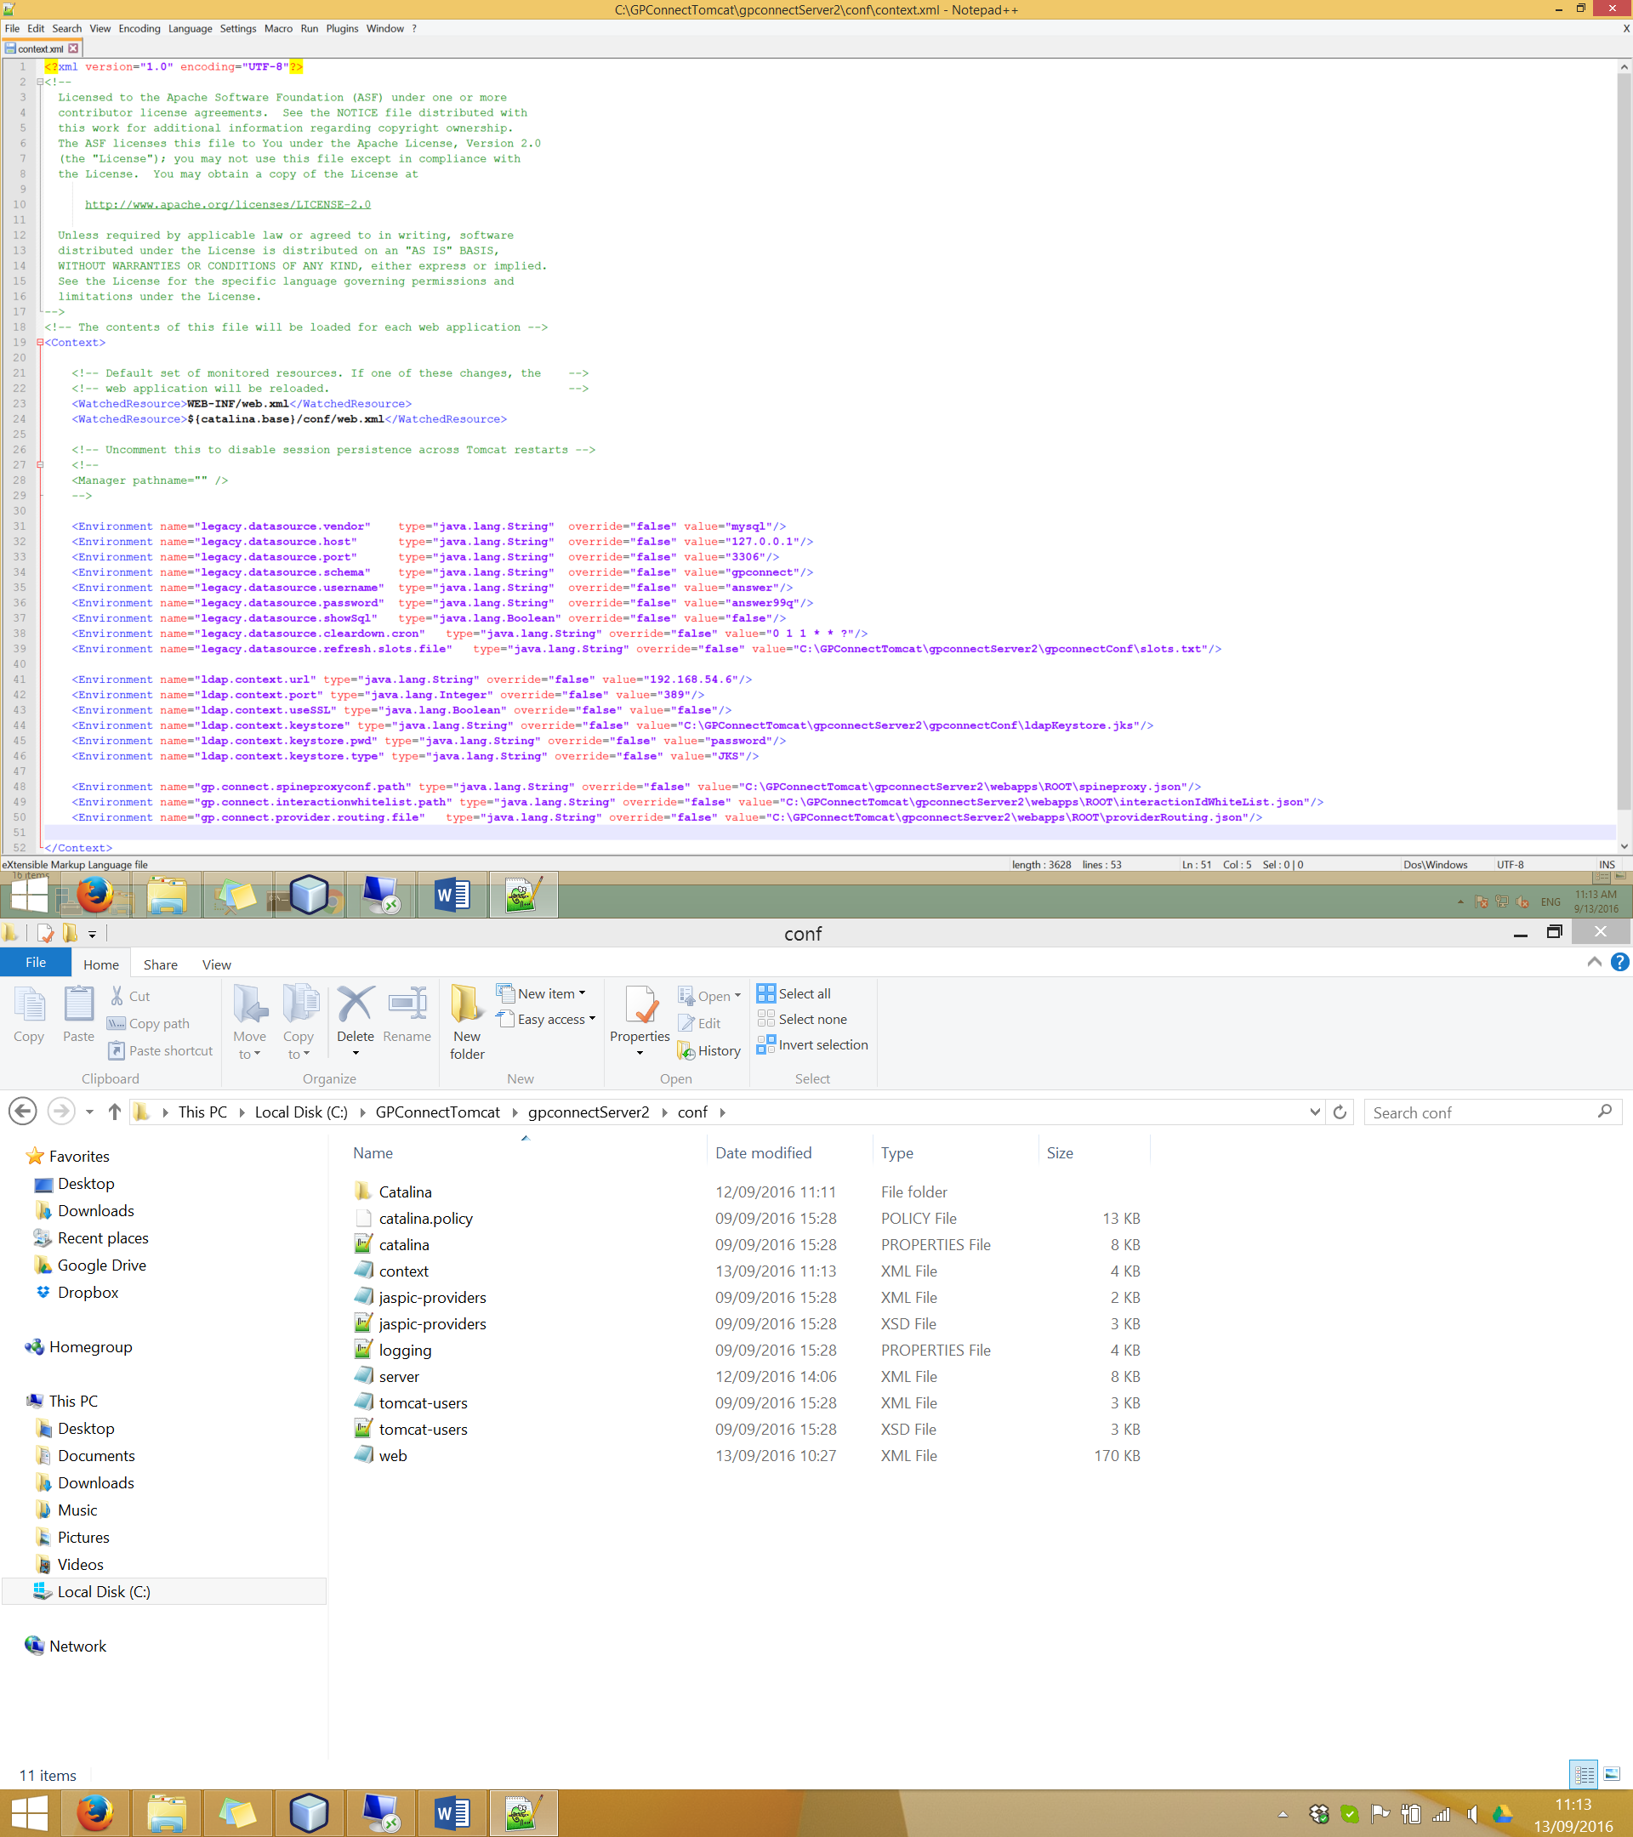

6. You need to add the default tomcat CORS filter to allow cross origin calls between the different server ports. To do this add the following filter configuration XML to the “web.xml” file within the server “conf” folder:

<filter>

<filter-name>CorsFilter</filter-name>

<filter-class>org.apache.catalina.filters.CorsFilter</filter-class>

</filter>

<filter-mapping>

<filter-name>CorsFilter</filter-name>

<url-pattern>/*</url-pattern>

</filter-mapping>

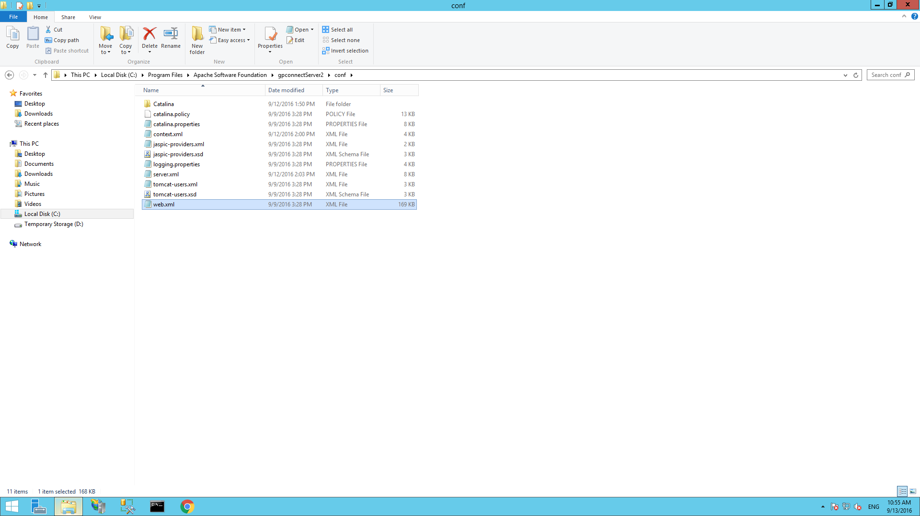

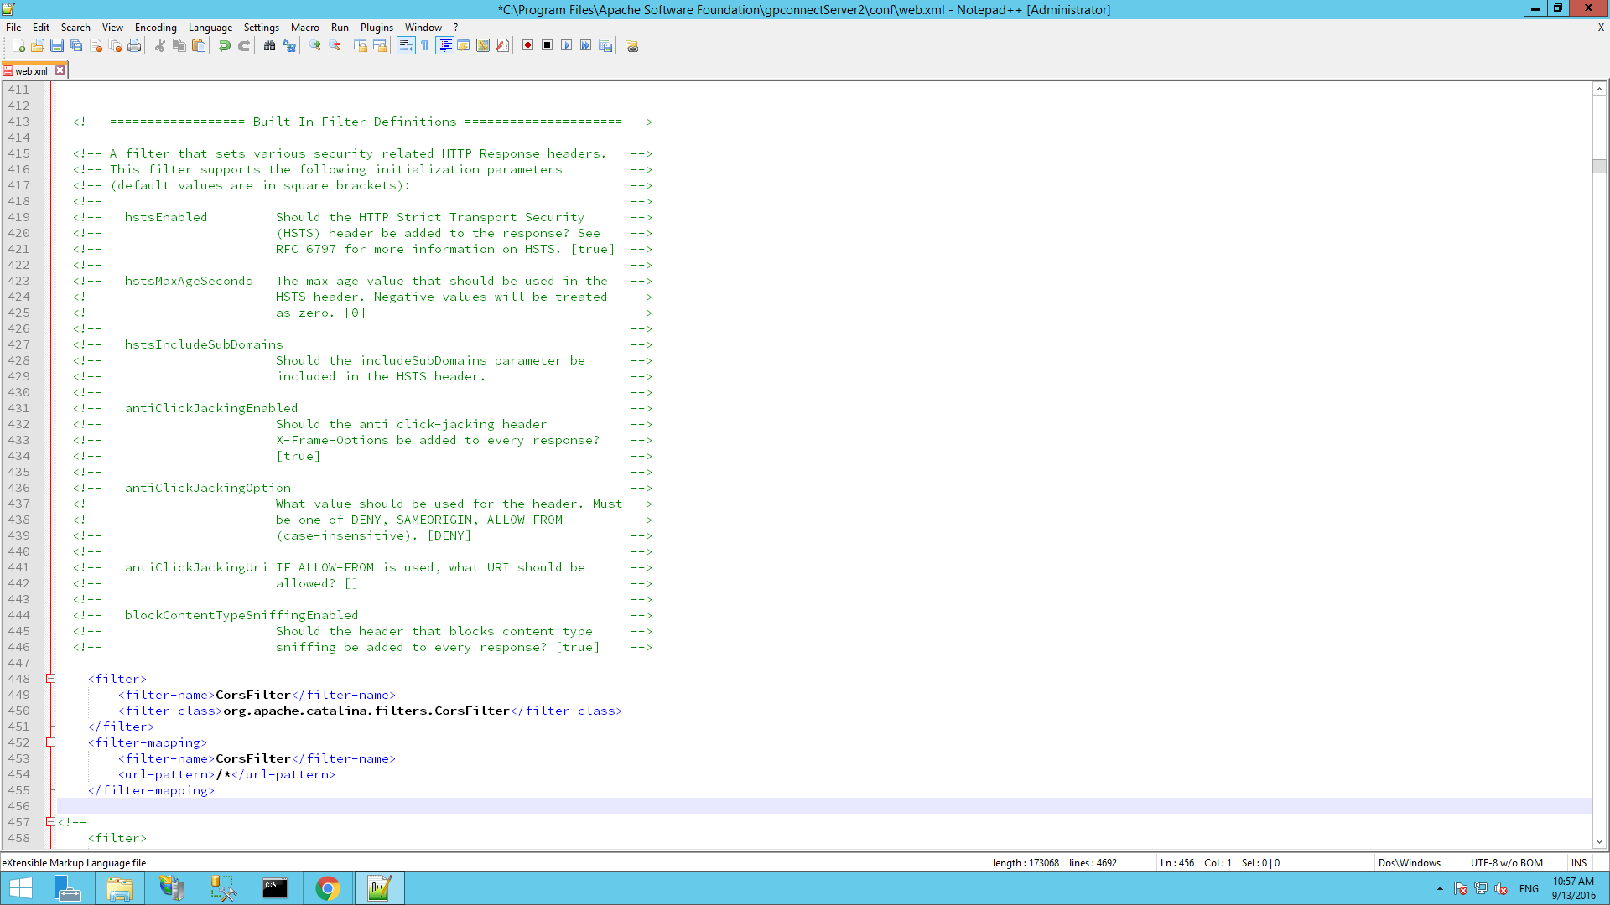

7. You have now setup a basic tomcat server with the GP Connect Demonstrator installed. To run the server go to the tomcat servers “bin” folder and double click the “startup.bat” file which should start the tomcat server.

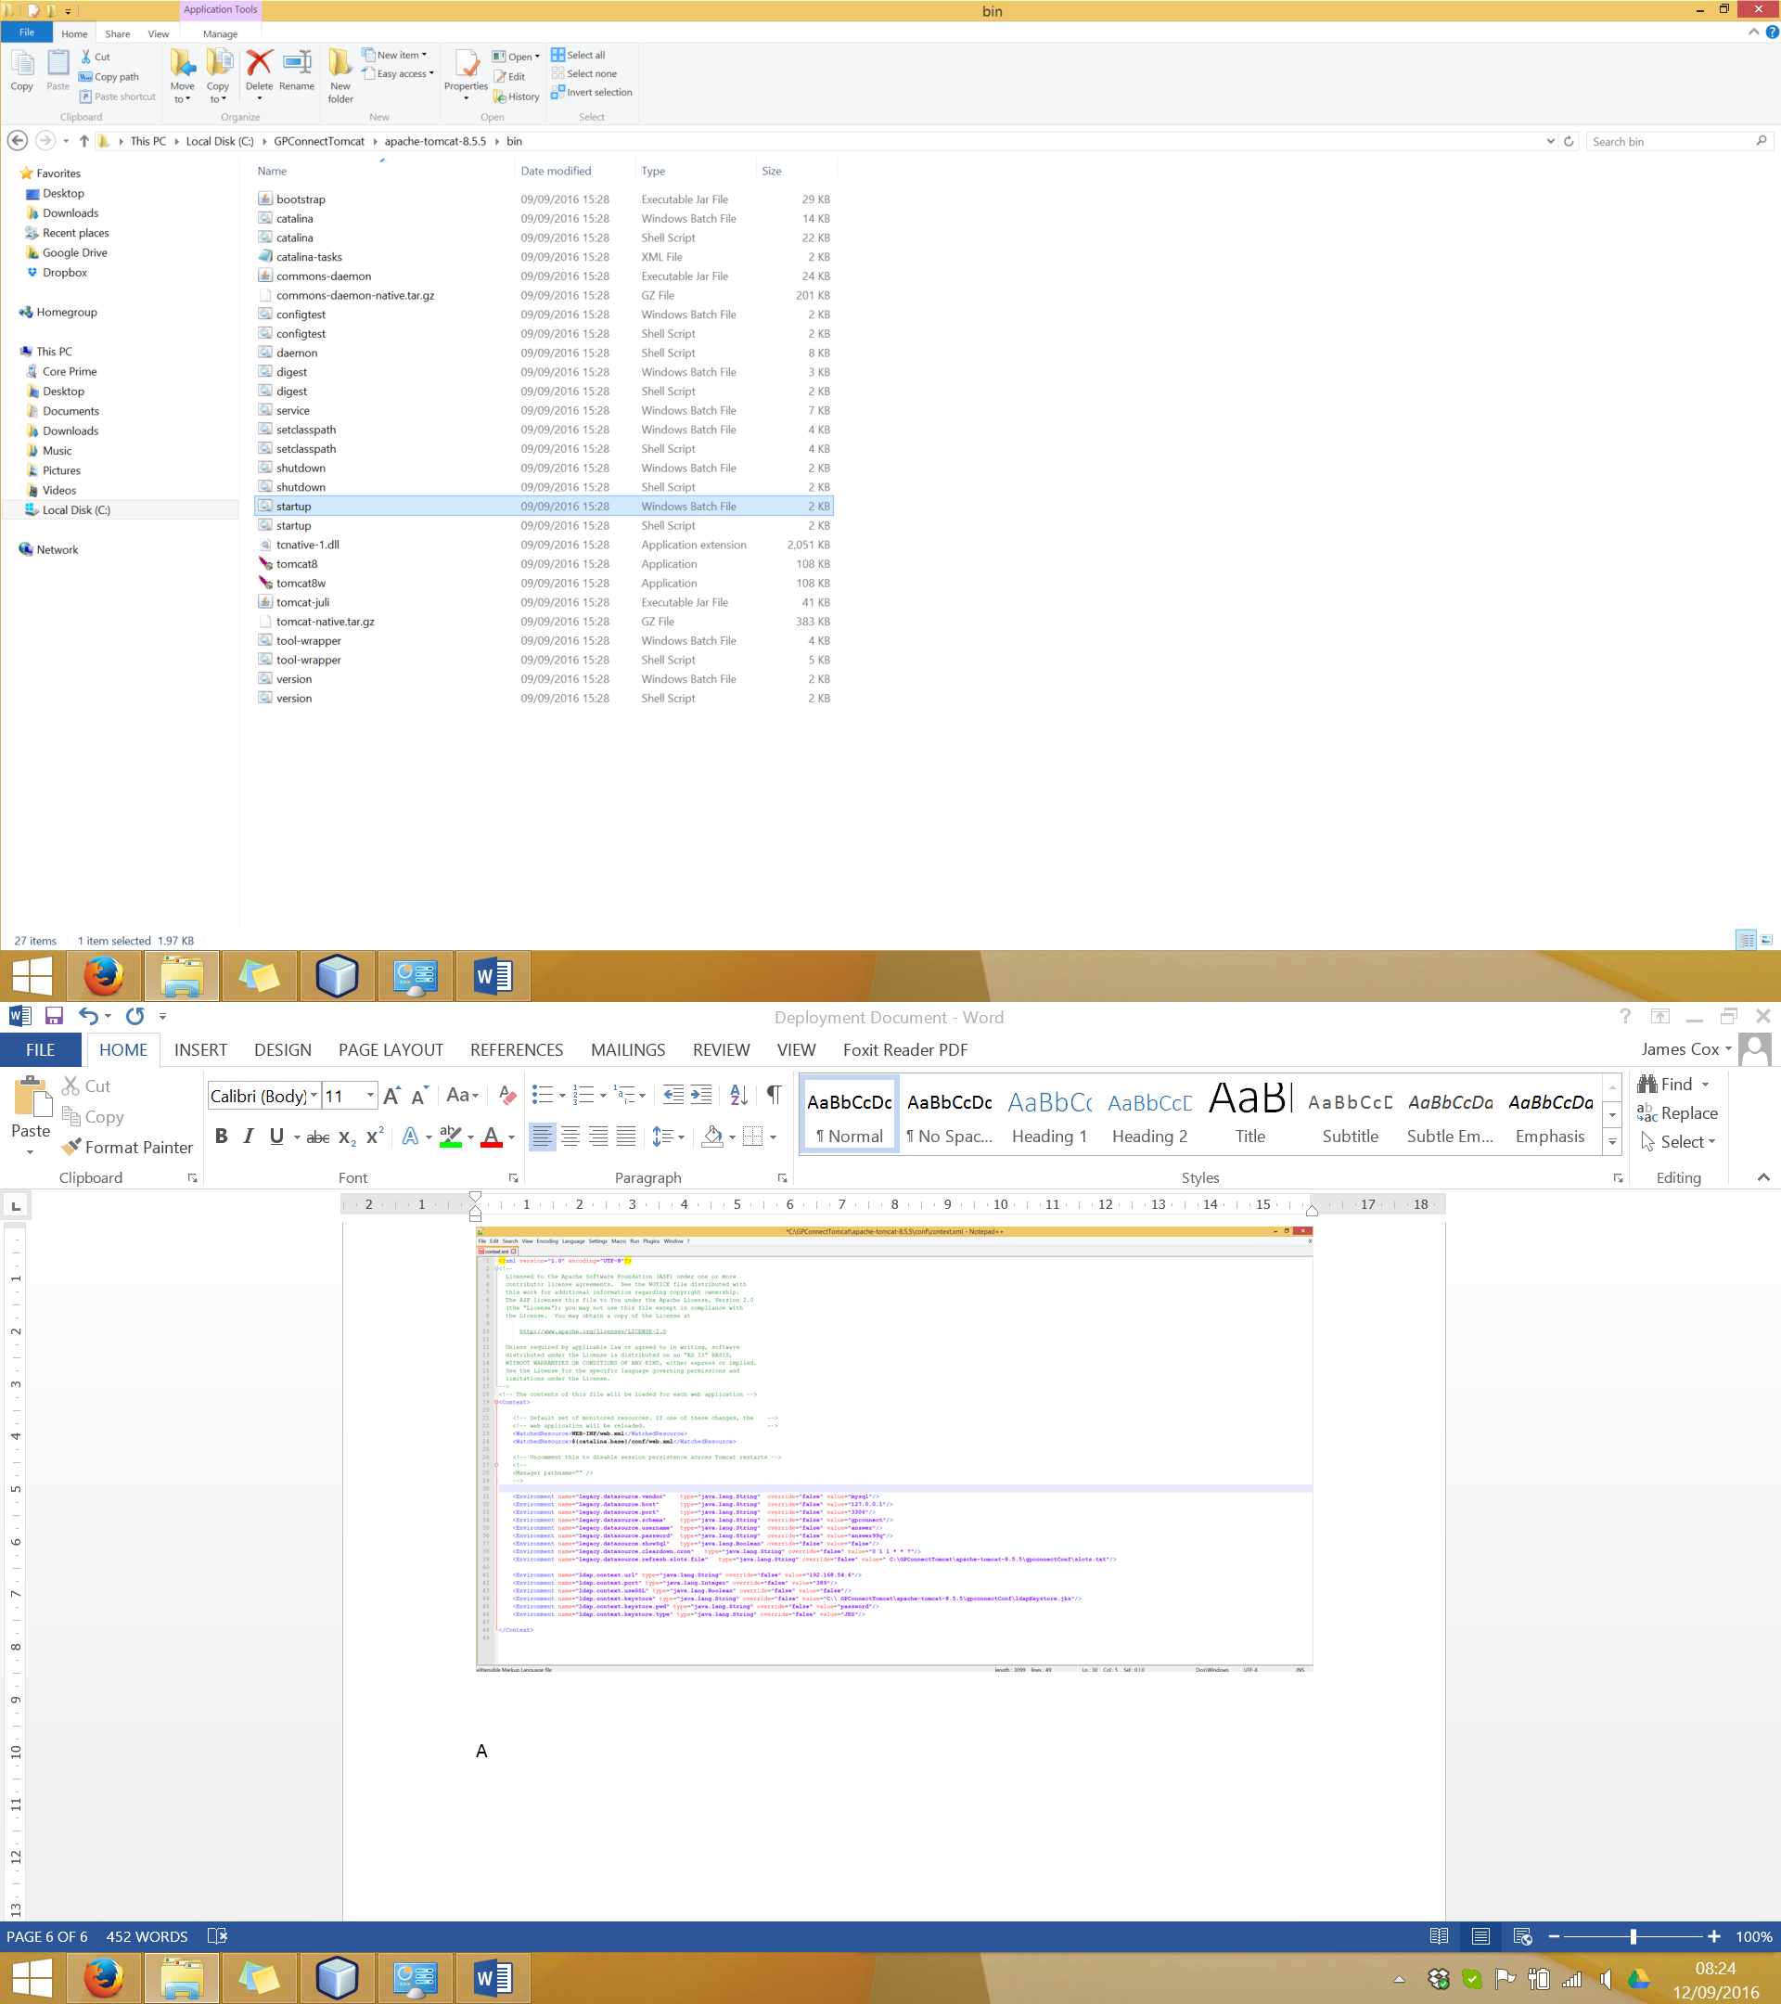

You should now be able to go to the following URL to see your running instance of the GP Connect Demonstrator:

<http://localhost:8080/>

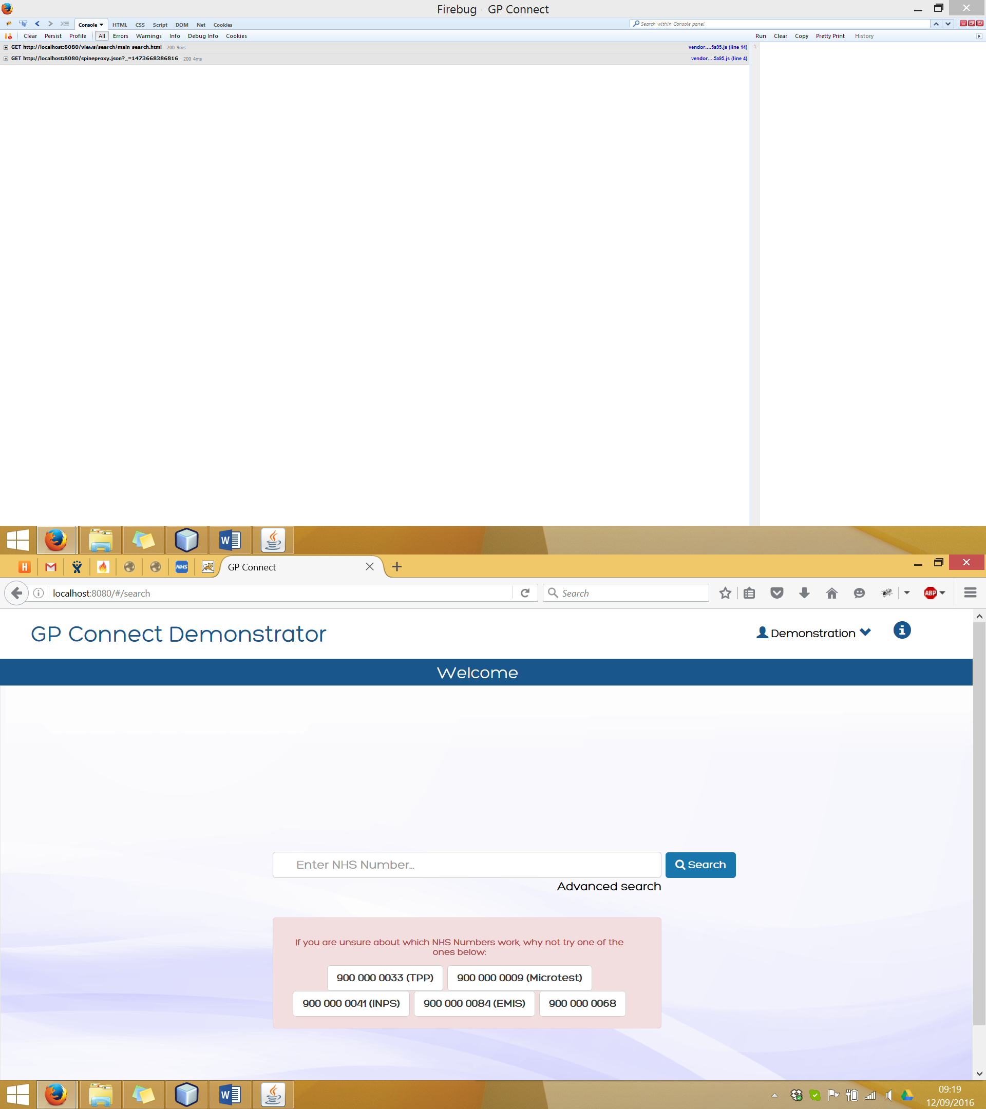

**Additional Information**

**The Slots File**

The “Slots.txt” file is located in the project root folder and is not included in the WAR file so needs to be copied to the server manually and then referenced in the configuration.

The “Slots.txt” file is important as it is use to build new slots as part of the system clear down process. The clear down runs every night and clears down all the appointments and slots and then re-builds new slots based on the templated slots within the “Slots.txt” file. This file is loaded before the clear down is done so can be changed without re-starting the server if you want to change the slots that are created once the clear down has been performed.

NOTE: The clear down is also performed when the server is started so that the available slots in the database start from the current date.

Within the “Slots.txt” file the format of the rows are as follows:

* Number of days from current date.
* Start Hour (0-23)
* Start Minute (0-59)
* Start Seconds (0-59)
* End Hour (0-23)
* End Minute (0-59)
* End Seconds (0-59)
* Slot Type Code
* Slot Type Description
* Practitioner internal ID
* Slot status (FREE/BUSY)

0,9,0,0,9,30,0,408443003,General medical practice,2,FREE

0,9,30,0,10,0,0,408443003,General medical practice,2,FREE

0,10,0,0,10,30,0,408443003,General medical practice,2,FREE

**Interaction White List**

The following file can be found in the deployed WAR file, “interactionIdWhiteList.json”. This contains the list of allowed interactionIds for the GP Connect Demonstrator. If the interactionId passed by the client application in the request header is not in the white list the backend of the demonstrator will return an error to the client.

This configuration has been done in a JSON format to make expansion and enhancement of the configuration easier if ever required, for example restricting endpoints to certain client asid’s.

**Local Endpoint Lookup Configuration**

The “providerRouting.json” file located in the deployed WAR file contains configuration for the local system ASID, the path for the spine proxy and the lookup values for the federated practices which the system can lookup the endpoint for when sending tasks.